DANANG UNIVERSITY OF SCIENCE AND TECHNOLOGY

**THE FACULTY OF ADVANCED SCIENCE AND TECHNOLOGY**



**CAPSTONE PROJECT REPORT**

**APPLYING ARTIFICIAL INTELLIGENCE IN ANALYZING FACIAL AGING SEVERITY AND RECOMMENDING SKINCARE PRODUCTS**

|  |  |  |
| --- | --- | --- |
| **Students:** |  | **LE Thi Hoai Luong 20PFIEV3**  **TRAN Ngoc Huy 20PFIEV3** |

|  |  |  |
| --- | --- | --- |
| **Supervisor:**  **Co-Supervisor:** |  | **Dr. NGUYEN Thi Anh Thu**  **Assoc. Prof. Dr. PHAM Van Tuan** |

**Danang, June 2025**

SUPERVISORS’S COMMENT

REVIEWERS’S COMMENT

ABSTRACT

Facial aging is a natural and complex process, yet its assessment often remains subjective and inconsistent, leading to challenges in personalized skincare. Current methods for evaluating skin aging primarily rely on visual inspection or expensive professional equipment, making precise and accessible self-assessment difficult for individuals. Furthermore, the vast array of skincare products available often overwhelms consumers, who struggle to identify optimal solutions tailored to their specific skin aging concerns.

This capstone project proposes an artificial intelligence-based system designed to accurately analyze facial aging severity and provide personalized skincare product recommendations. Our approach leverages deep learning, specifically Convolutional Neural Networks (CNNs), to objectively identify and classify various signs of aging, such as wrinkles, fine lines, age spots, and loss of skin elasticity, from facial images. The system integrates a robust image processing pipeline for facial detection, alignment, and normalization, ensuring consistent input for the AI model. Based on the comprehensive aging severity assessment, a recommendation engine is developed, utilizing content-based filtering techniques to suggest suitable skincare products from a curated database, considering their ingredients, benefits, and target skin concerns.

Experimental results demonstrate the efficacy of our proposed CNN model in accurately classifying facial aging severity across different levels. The integrated recommendation system effectively links these assessments to relevant skincare products, offering personalized solutions that address the user's specific aging characteristics. This system provides a convenient, objective, and accessible tool for individuals to understand their skin's aging condition and make informed decisions regarding their skincare regimen, thereby contributing to more effective and personalized dermatological care.

|  |  |
| --- | --- |
| DA NANG UNIVERSITY  **UNIVERSITY OF SCIENCE AND TECHNOLOGY**  FACULTY OF ADVANCED SCIENCE AND TECHNOLOGY | **THE SOCIALIST REPUBLIC OF VIETNAM**  Independence – Freedom – Happiness |

GRADUATION CAPSTONE PROJECT REQUIREMENTS

Student Name: Le Thi Hoai Luong

Student Card ID: 123200067 Class: 20PFIEV3

Department: PFIEV Major: Software Engineering

Student: Tran Ngoc Huy

Student Card ID: 123200104 Class: 20PFIEV3

Department: PFIEV Major: Software Engineering

1. Project title: Applying Artficial Intelligence in Analyzing Facial aging Severity and Recommending Skincare products
2. Project’s result: ☐ are protected by an intellectual property agreement.
3. Project’s content:

Build a system with the following functions:

* Applying AI to analyze facial aging signs:
* Detection and Severity Assessment of Facial Wrinkles
* Detection and Analysis of Facial Pigmentation
* Detection and Assessment of Facial Skin Dryness
* Overall Facial Aging Severity Assessment
* AgingSkincare Product Recommendation System

1. Supervisors:

PHAM Van Tuan, Assoc. Prof. Dr

*Director, Institute of Education and Engineering – Technology LYDINC, L.Y.D.I.N.C One Member Co., Ltd.*

NGUYEN Thi Anh Thu, Dr

*Vice Dean, The Faculty of Advanced Science and Technology, Da Nang University of Science and Technology – The University of Danang.*

1. Date of assignment: 21/02/2025
2. Date of completion: 19/06/2025

Danang, June 19th, 2025

**Head of Division.....................** **Instructor**

ACKNOWLEDGMENT

First and foremost, I would like to express my deepest gratitude to my esteemed supervisors, Assoc. Prof. Dr. PHAM Van Tuan and Dr. NGUYEN Thi Anh Thu, for their invaluable guidance, unwavering support, and profound insights throughout the entire duration of this capstone project. Their extensive knowledge, meticulous feedback, and constant encouragement were absolutely instrumental in shaping the direction of this research, navigating complex challenges, and pushing the boundaries of my academic and technical understanding. Their dedication, coupled with their leadership within LYDINC Institute of Education, Science, and Technology and the Faculty of Advanced Science and Technology respectively, significantly fostered an academic environment that encouraged innovative research and intellectual growth, truly inspiring me.

A special thank you is extended to Dr. DINH Thi Thu from the Dermatology Department, TTH Quang Binh General Hospital. Her expert medical insights into facial aging, nuanced understanding of skin conditions, and practical knowledge of skincare product characteristics were critically important for ensuring the accuracy, relevance, and clinical applicability of the recommendation system developed in this project. Her willingness to share her professional expertise significantly enhanced the depth and quality of my research.

Finally, I am profoundly thankful to The University of Danang – University of Science and Technology, and specifically the Faculty of Advanced Science and Technology, for providing the necessary resources, cutting-edge facilities, and an exceptional academic environment that greatly facilitated the execution of this research.

This project would not have been possible without the collective support, guidance, and contributions of all these individuals and institutions.

**GUARANTEE**

We guarantee:

1. This capstone project has been done by ourselves in the year 2025 at Institute of Education and Engineering - Technology LYDINC, L.Y.D.I.N.C One Member Co., Ltd. under supervision of Assoc. Prof. Dr. PHAM Van Tuan and Dr.NGUYEN Thi Anh Thu, Vice Dean of the Faculty of Advanced Science and Technology, Danang University of Science and Technology."
2. All references, which are used in this project, are quoted with author’s name, project’s name, time, and location to publish clearly and faithfully.
3. We will take full responsibility if there are any invalid copy issues as well as academic fraud.

Students,

LE Thi Hoai Luong

TRAN Ngoc Huy

**TABLE OF CONTENTS**

CHAPTER 1: INTRODUCTION 1

1.1. Motivation 1

1.2. Contribution of the Thesis 4

1.3. Organization of the Thesis 6

1.4. Work distribution 7

CHAPTER 2: REVIEW OF LITERATURE 9

2.1. Understanding skin aging and its manifestation 9

2.1.1. Intrinsic and extrinsic factors of skin aging 9

2.1.2. Specific manifestations of facial aging 13

2.2. Artificial intelligence and computer vision in dermatological analysis 19

2.2.1. Introduction to artificial intelligence and machine learning 19

2.2.2. Deep learning and Convolutional Neural Networks (CNNs) 20

2.2.3. Image preprocessing techniques 22

2.2.4. AI-Based facial aging assessment systems 24

2.2.5. Skincare product recommendation systems 25

CHAPTER 3: PROPOSED METHODS 28

3.1. System architecture overview 28

3.2. Model architecture 29

3.3. Aging indicator detection and assessment methods 31

3.3.1. Wrinkle detection and severity assessment 31

3.3.2. Pigmentation spot detection and classification 33

3.3.3. Skin dryness evaluation and measurement 35

3.4. Overall facial aging assessment methodology 37

3.5. Skincare product recommendation system 38

3.5.1. Content-Based filtering algorithm 38

3.5.2. Ingredient-to-problem mapping 38

3.5.3. Cosine similarity implementation 39

3.5.4. Product database integration 39

3.6. System implementation and deployment architecture 40

3.6.1. Backend infrastructure 40

3.6.2. Scalability and performance optimization 41

3.6.3. Application interface 41

CHAPTER 4: EXPERIMENTS AND EVALUATION 50

4.1. Dataset characteristics 50

4.1.1. FFHQ-Wrinkle Dataset 50

4.1.2. Asian consumer dataset 51

4.1.3. Skincare product database 52

4.1.4. Data partitioning strategy 53

4.2. Evaluation metric 54

4.2.1. Overall aging scrore methology 54

4.2.2. Recommendation system evaluation 56

4.3. Evaluation of facial aging classification performance 56

4.3.1. General classification report (Overall metrics) 57

4.3.2. Overall classification performance 59

4.3.3. Performance by specific age groups 60

4.4. Qualitative results and user studies 67

4.4.1. Expert validation studies 67

4.4.2. User satisfaction and engagement studies 67

CHAPTER 5: CONCLUSION AND FUTURE DEVELOPMENT 69

5.1. Summary of research accomplishments 69

5.2. Research impact and implications 69

5.3. Final conclusions and recommendations 69

**TABLE INDEX**

*Table 1: Work distribution 8*

*Table 2: Wrinkle Severity Rating Scale (WSRS) 15*

*Table 3: Wrinkle severity grading scale based on a composite score combining quantitative metrics such as wrinkle area, depth, density, and length 33*

*Table 4: Pigmentation severity grading scale based on five levels (0 to 4) 35*

*Table 5: Dryness severity scale ranging from Level 0 to Level 4, defined by measurable features including number of flaking spots, flaking area (mm²), surface roughness, and brightness variation. 37*

*Table 6: Class-wise Performance Analysis 55*

*Table 7: Classification report 57*

*Table 8: Survey results on user satisfaction and acceptance of skincare recommendations, categorized by demographic groups (age and gender) 68*

**IMAGE INDEX**

*Figure 1: Younger skin and Aging skin 10*

*Figure 2: Illustration of the effects of UV radiation and pollution on the microscopic structure of the skin. 12*

*Figure 3: Illustration of typical facial wrinkle regions categorized by expression and type. 15*

*Figure 4: Illustrated crease sverity scale 17*

*Figure 5:Close-up images of different types of pigmented lesions on facial skin, illustrating clear morphological differences 17*

*Figure 6:Dry skin due to aging 19*

*Figure 7: Annotated image showing labeled regions of facial hyperpigmentation (“dark_spot”), used for training or evaluating machine learning models for skin pigmentation analysis. 21*

*Figure 8: Preprocessing steps in facial image analysis for skin assessmen 25*

*Figure 9: Illustration of a Convolutional Neural Network (CNN) architecture used for facial skin analysis. 27*

*Figure 10: Structure and metadata of the “ffhq-wrinkle-dataset” used for facial wrinkle detection tasks. 38*

*Figure 11: Stages of facial wrinkle detection using a deep learning pipeline. 43*

*Figure 12: A grading scale illustrating different levels of facial pigmentation, from Grade 0 to Grade 4 46*

*Figure 13: Django Rest Framework 62*

*Figure 14: User information input interface in the facial skin analysis application 63*

*Figure 15: Skin scan preparation instruction screen 64*

*Figure 16: Face capture screen during skin scanning process 65*

*Figure 17: Analysis results and overview evaluation screen 66*

*Figure 18:Wrinkle analysis screen 67*

*Figure 19: Pigmentation spot analysis screen 68*

*Figure 20: Skin moisture level analysis screen 69*

*Figure 21: Skincare routine recommendation interface 70*

*Figure 22: Overall confusion matrix of facial age group classification. 79*

*Figure 23: Confusion matrix for age group 20-35 years old. 81*

*Figure 24: Confusion matrix for age group 36-45 years old. 82*

*Figure 25: Confusion matrix for age group 46-55 years old. 83*

*Figure 26: Confusion matrix for age group 56-65 years old. 84*

*Figure 27: Confusion matrix for age group 65+ years old. 85*

**LIST OF ABBREVIATION**

|  |  |
| --- | --- |
| *Abbreviation* | *Full Term* |
| *AI* | *Artificial Intelligence* |
| *API* | *Application Programming Interface* |
| *BCE* | *Binary Cross-Entropy* |
| *CLAHE* | *Contrast Limited Adaptive Histogram Equalization* |
| *CNN* | *Convolutional Neural Network* |
| *CPU* | *Central Processing Unit* |
| *DL* | *Deep Learning* |
| *GLCM* | *Gray-Level Co-occurrence Matrix* |
| *GPU* | *Graphics Processing Unit* |
| *HSV* | *Hue, Saturation, Value (color model)* |
| *Lab* | *Lightness, a-color component, b-color component (color model)* |
| *LBP* | *Local Binary Patterns* |
| *ML* | *Machine Learning* |
| *MMPs* | *Matrix Metalloproteinases* |
| *MSE* | *Mean Squared Error* |
| *MTCNN* | *Multi-task Cascaded Convolutional Networks* |
| *NMFs* | *Natural Moisturizing Factors* |
| *PIH* | *Post-Inflammatory Hyperpigmentation* |
| *PM2.5* | *Particulate Matter 2.5* |
| *ReLU* | *Rectified Linear Unit* |
| *RGB* | *Red, Green, Blue (color model)* |
| *ROS* | *Reactive Oxygen Species* |
| *SGD* | *Stochastic Gradient Descent* |
| *SSD* | *Single Shot Detector* |
| *TEWL* | *Transepidermal Water Loss* |
| *UI* | *User Interface* |
| *UV* | *Ultraviolet* |
| *VOCs* | *Volatile Organic Compounds* |
| *WSRS* | *Wrinkle Severity Rating Scale* |

# INTRODUCTION

## Motivation

Vietnam is experiencing a significant demographic shift, with its population rapidly entering an aging phase. Projections indicate that the proportion of individuals over 60 years old reached 10% by 2017 and is continuing to rise, signaling an increasing demand for solutions related to aging concerns [1]. This demographic trend coincides with a robust and expanding skincare market in Vietnam, which is projected to grow substantially from USD 852.18 million in 2022 to USD 1,808.21 million by 2030, demonstrating a clear market need for effective skincare solutions [2].

Despite the growing market, the assessment of facial aging remains largely subjective and inconsistent. Current methods often rely on visual inspection or expensive professional equipment, making precise and accessible self-assessment challenging for individuals. Furthermore, consumers face an overwhelming array of skincare products, struggling to identify optimal solutions tailored to their specific aging concerns.

Compounding these challenges are various extrinsic factors prevalent in Vietnam that accelerate skin aging. The country's tropical climate exposes its population to high levels of UV radiation, with indices frequently reaching "very high to extreme" levels (often 8-10, especially in summer), significantly increasing the risk of sunburn and premature skin aging [3]. For instance, Ho Chi Minh City typically records UV indices from 7.5-10 [4], and the World Health Organization (WHO) states that UV indices from 7.5-10.4 are considered "very high," where just 15 minutes of unprotected exposure can cause skin burns [5]. Additionally, Vietnam ranks among the top 15 countries with the highest air pollution levels globally [6], particularly in major cities like Hanoi and Ho Chi Minh City, where PM2.5 levels often exceed safe limits. Pollution from industry and traffic increases the risk of skin damage [5], with research indicating that air pollution increases skin inflammation, wrinkles, and dark spots, especially in urban areas [7]. Lifestyle habits such as high smoking rates among Vietnamese men (about 45.3% [8]) and increasing alcohol consumption (reaching 8.9 liters of pure alcohol per person per year in 2017, higher than the global average [10], [11]) also contribute to premature skin aging and damage by causing dehydration and increasing the risk of related diseases [9].

Given the natural and complex process of facial aging, exacerbated by environmental and lifestyle factors, and the limitations of current assessment methods, there is a critical need for an objective, accessible, and personalized approach to understanding and addressing skin aging. This project is motivated by the opportunity to leverage artificial intelligence to accurately analyze facial aging severity and provide tailored skincare product recommendations, thereby empowering individuals to make informed decisions for their skin health and well-being.

Building upon the identified challenges in objective skin aging assessment and personalized product recommendation, coupled with the significant practical needs within the Vietnamese context, this research sets forth a series of specific, measurable, achievable, relevant, and time-bound (SMART) objectives.

The foremost objective is to apply a robust AI model for objective facial aging severity analysis based on specific key indicators. This entails the meticulous design, intricate implementation, and rigorous optimization of a deep learning-based model, primarily leveraging state-of-the-art Convolutional Neural Networks (CNNs). The model's core function will be to accurately identify, precisely segment, and quantitatively assess three critical facial aging signs: wrinkles, pigmentation spots (such as age spots or hyperpigmentation), and skin dryness. For each identified sign, the system will assign a specific severity score or classify it into predefined levels. A critical aspect of this objective involves engineering the model to then synthesize these individual scores into a comprehensive overall facial aging severity level, providing an objective and consistently reproducible assessment that fundamentally transcends the inherent subjectivity and variability of traditional manual evaluations. Furthermore, significant attention will be dedicated to designing and implementing a robust image processing pipeline to preprocess facial images, ensuring high-quality input for the AI model and promoting robustness against common real-world variations in lighting conditions, head pose, and facial expressions.

The second pivotal objective is to develop an intelligent skincare product recommendation method that directly leverages the insights from this multi-faceted aging analysis. Based on the granular and objective output provided by the facial aging analysis module – specifically the individual scores for wrinkles, pigmentation, and dryness, along with the overall aging severity level – this objective focuses on developing a sophisticated recommendation engine. This engine will strategically employ data-driven approaches, integrating a blend of content-based filtering techniques (matching product attributes like active ingredients and benefits to the identified skin concerns) with rule-based logic meticulously informed by established dermatological expertise and the specific needs identified in the Vietnamese market. The ultimate aim is to generate highly personalized skincare product suggestions. These recommendations will be precisely tailored to directly address the user's specific aging concerns (e.g., a product for reducing wrinkles, another for fading dark spots, or one for improving skin hydration), accommodate their unique skin type, and potentially incorporate other user-defined preferences such as preferred ingredients, brand loyalty, or budget constraints. This will be achieved by integrating the engine with a comprehensive, meticulously curated product database, ensuring the relevance and efficacy of all suggestions.

Furthermore, a crucial objective is to comprehensively evaluate the performance and practical utility of the integrated system. This entails a rigorous, multi-faceted assessment of the proposed system's efficacy and reliability. For the AI aging analysis module, its performance will be quantitatively assessed using a battery of standard machine learning metrics, including overall accuracy, precision, recall, F1-score, and detailed confusion matrices, applied to a carefully curated and independent test dataset, specifically evaluating its ability to detect and score wrinkles, pigmentation, and dryness. For the recommendation engine, evaluation will involve both quantitative metrics (where applicable, e.g., ranking accuracy) and extensive qualitative assessment. The latter will involve gathering expert feedback and user satisfaction ratings to gauge the relevance, personalization, and actionable utility of the generated skincare suggestions based on the three targeted aging signs. The holistic practical utility and overall user satisfaction will also be critically analyzed to ensure the system meets real-world needs.

Finally, to maximize accessibility and foster genuine user engagement, a crucial objective is to design a user-centric interface for seamless interaction. This involves developing an intuitive, aesthetically pleasing, and highly functional platform. This interface will be engineered to allow users to effortlessly upload their facial images, receive a clear, comprehensive, and easy-to-understand report detailing their individual scores for wrinkles, pigmentation spots, and skin dryness, alongside their overall aging severity level. Subsequently, they will be able to explore their personalized product recommendations with minimal effort, ultimately empowering them to make informed and confident decisions regarding their skincare regimen.

## Contribution of the Thesis

This thesis is positioned to make several distinct and significant contributions across the interdisciplinary domains of artificial intelligence, computer vision, and personalized skincare, addressing crucial gaps in current practices.

Firstly, a primary contribution lies in establishing an objective and accessible aging assessment methodology focused on key indicators. By developing a robust AI-powered solution, this project directly advances the state-of-the-art in dermatological diagnostics. It offers a consistently objective and quantifiable assessment of facial aging severity by specifically analyzing and scoring wrinkles, pigmentation spots, and skin dryness, then synthesizing these into an overall aging level. This directly addresses the inherent limitations of subjective manual evaluations and the high cost and limited accessibility of specialized clinical instruments, thereby democratizing precise skin insights for the general public regarding these specific concerns.

Secondly, this research will deliver a novel personalized skincare recommendation framework directly informed by detailed multi-indicator aging diagnostics. Moving beyond generic or broad product suggestions, the project's framework uniquely leverages the AI-driven, granular analysis of wrinkles, pigmentation, and dryness to generate highly tailored product recommendations. This personalized approach empowers consumers to make demonstrably more informed, effective, and targeted skincare choices, ultimately leading to optimized outcomes and reduced expenditure on unsuitable products. The integration of precise, multi-factor analysis with bespoke recommendations represents a significant step towards truly individualized skincare solutions.

Thirdly, this work serves as a compelling practical application of state-of-the-art deep learning in dermatology for specific skin attributes. By successfully implementing and validating advanced Convolutional Neural Networks (CNNs) for intricate dermatological image analysis, specifically for detecting and quantifying wrinkles, pigmentation spots, and visual cues of dryness, the thesis showcases the immense potential of these computational techniques for precise feature extraction, complex pattern recognition, and classification within complex biological systems like human skin. This contributes valuable empirical evidence to the growing body of literature on AI in healthcare.

Fourthly, a notable contribution stems from the project's direct relevance to local market needs and demographic specifics. By meticulously grounding its motivation, problem identification, and practical needs within the specific context of the Vietnamese population and local skincare market, the project offers highly relevant insights and a tailored solution. This approach explicitly considers unique regional factors such as high UV exposure and pervasive air pollution, ensuring the applicability and immediate utility of the developed system for its target users in addressing their primary skin aging concerns.

Finally, the meticulously developed models, carefully curated datasets, and refined methodologies resulting from this research will collectively establish a robust foundational platform for future advancements. This foundation can pave the way for numerous future research directions, including the incorporation of additional skin parameters (e.g., elasticity, pore size), the development of broader skin condition diagnostics beyond aging, the implementation of longitudinal skin aging tracking capabilities over time, and the sophisticated integration with advanced multimodal data sources, such as detailed user-reported preferences or genomic data, to create even more comprehensive personalized skincare solutions.

## Organization of the Thesis

This thesis is systematically organized into five main chapters to facilitate a clear and comprehensive understanding of the research conducted:

* Chapter 1: Introduction provides an extensive overview of the current global and local context of skin aging, highlights the practical needs driving this research, details the specific skin parameters of concern, and analyzes relevant user psychology. It concludes by outlining the specific research objectives, the defined scope of the study, and the key contributions of this thesis.
* Chapter 2: Background and Related Work delves into the theoretical underpinnings of facial skin aging, exploring both intrinsic and extrinsic factors. It then provides a detailed review of fundamental concepts in Artificial Intelligence, Machine Learning, and Deep Learning, with a particular focus on Convolutional Neural Networks and their applications in computer vision. Furthermore, this chapter critically examines existing diagnostic technologies, published scientific research, and current commercial products related to automated skin analysis and intelligent recommendation systems.
* Chapter 3: Proposed Method elucidates the comprehensive methodology employed in this project. This chapter elaborates on the system architecture, detailed procedures for data acquisition and preprocessing (including image normalization and annotation strategies), the design and implementation of algorithms, the facial aging severity assessment approach, and the algorithms underpinning the personalized skincare product recommendation engine.
* Chapter 4: Experiments and Evaluation presents the empirical results and performance analysis of the system. This includes a description of the experimental setup, the characteristics of the datasets used for training, validation, and testing, and a thorough explanation of the evaluation metrics. The chapter then discusses the quantitative and qualitative outcomes of the facial aging analysis and the skincare product recommendation system, comparing them against established benchmarks where applicable.
* Chapter 5: Conclusion and Future Work summarizes the major findings and accomplishments of this research. It highlights the successful fulfillment of the stated objectives, discusses the implications of the results, acknowledges the limitations encountered during the project, and proposes promising directions for future research and enhancements to the system.

## Work distribution

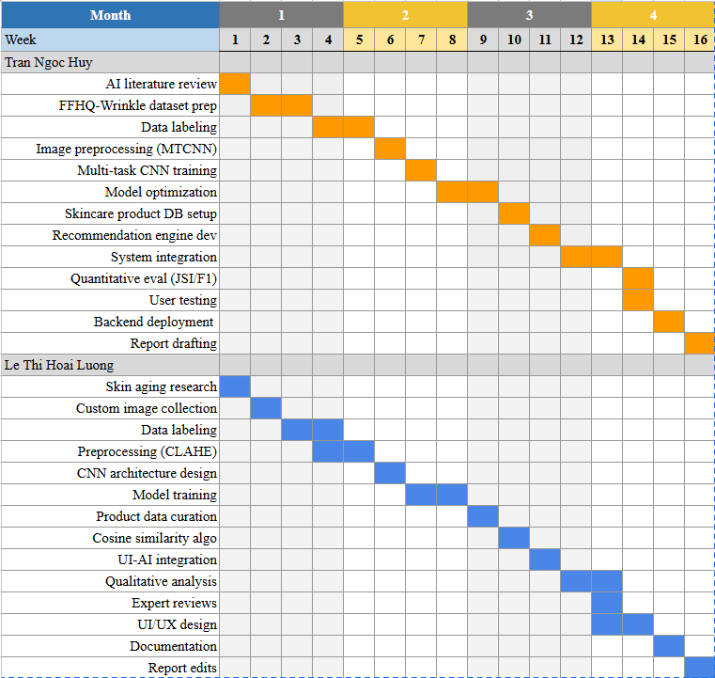

**Table 1: Work distribution**

# REVIEW OF LITERATURE

This chapter provides a comprehensive review of the theoretical foundations and existing research relevant to the proposed AI-integrated system for facial aging analysis and skincare product recommendation. It is structured to build a clear understanding of the dermatological aspects of skin aging, the underlying principles of Artificial Intelligence and Computer Vision employed, and the current landscape of related scientific studies and commercial applications.

## Understanding skin aging and its manifestation

Skin aging is a multifaceted and progressive biological phenomenon characterized by a gradual decline in the skin's structural integrity and physiological function. This intricate process culminates in visible changes in skin appearance and texture. The mechanisms driving skin aging are broadly categorized into two synergistic yet distinct pathways: intrinsic aging, an internal chronological process, and extrinsic aging, primarily driven by environmental and lifestyle factors. A comprehensive understanding of these pathways and their specific visible manifestations – particularly wrinkles, pigmentation spots, and skin dryness – is paramount for the development of accurate diagnostic tools and personalized skincare solutions.

### Intrinsic and extrinsic factors of skin aging

Intrinsic aging, often referred to as chronological aging, is an genetically predetermined and inevitable biological process. It is characterized by inherent cellular and molecular changes occurring over time, irrespective of external influences. At the cellular level, intrinsic aging involves telomere shortening, a process where the protective caps at the ends of chromosomes progressively shorten with each cell division, eventually leading to cellular senescence. Senescent cells lose their ability to divide and accumulate, contributing to tissue dysfunction. Furthermore, there is a natural decline in the efficiency of cellular repair mechanisms, making the skin more vulnerable to damage over time. Histologically, the epidermis (outermost layer) gradually thins, and the dermal-epidermal junction, which facilitates nutrient exchange between the dermis and epidermis, flattens, impairing skin barrier function and nutrient delivery. Within the dermis (middle layer), there is a progressive decrease in both the number and activity of fibroblasts, the specialized cells responsible for producing extracellular matrix components. This leads to a quantitative and qualitative reduction in crucial structural proteins such as collagen (particularly Type I and III) and elastin fibers, which are indispensable for maintaining skin strength, elasticity, and resilience. The diminished synthesis of these proteins, coupled with their increased degradation by naturally occurring matrix metalloproteinases (MMPs), results in a significant loss of dermal volume, reduced skin elasticity, and the generalized appearance of fine lines and skin laxity. Additionally, a decline in glycosaminoglycans (e.g., hyaluronic acid), which are hydrophilic molecules vital for water retention, contributes directly to a natural 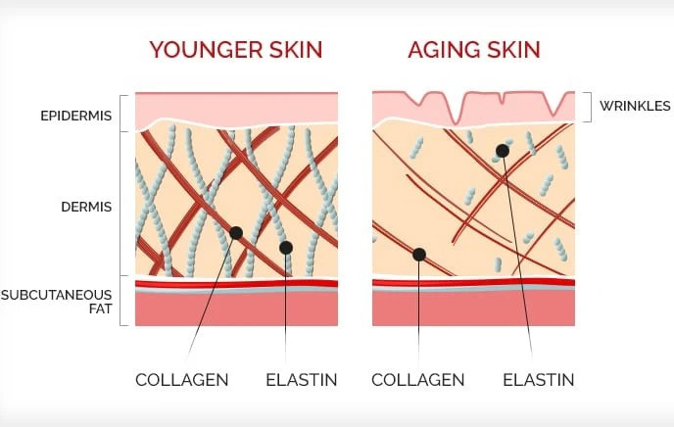reduction in skin hydration and overall plumpness, making the skin appear drier.

**Figure 1: Younger skin and Aging skin**

In stark contrast, extrinsic aging is primarily induced and significantly accelerated by cumulative exposure to external environmental stressors and detrimental lifestyle choices. These factors impose chronic oxidative stress and inflammation, profoundly impacting skin structure and function beyond the rate of intrinsic aging. The most dominant extrinsic factor is ultraviolet (UV) radiation, specifically UVA and UVB rays from sun exposure. Chronic UV exposure leads to the generation of abundant Reactive Oxygen Species (ROS), which are highly reactive molecules that cause direct oxidative damage to vital cellular components including DNA, proteins (such as collagen and elastin), and lipids within cell membranes. This oxidative stress not only directly degrades structural proteins but also triggers inflammatory responses and upregulates the activity of MMPs, leading to excessive and disorganized breakdown of the dermal extracellular matrix. This process results in characteristic photoaging features such as solar elastosis (an abnormal accumulation of degraded elastic material), the formation of deep wrinkles and furrows, skin sagging, and irregular pigmentation, often appearing as sunspots or hyperpigmentation.

Beyond UV radiation, environmental pollution constitutes another major extrinsic contributor to skin aging. Air pollutants, including particulate matter (PM2.5), volatile organic compounds (VOCs), heavy metals, and ground-level ozone, can penetrate the skin or generate free radicals upon contact. These pollutants induce oxidative stress, compromise the skin's crucial barrier function, and activate pro-inflammatory pathways. This chronic inflammation further accelerates collagen breakdown and triggers irregular melanogenesis (melanin production), leading to premature wrinkle formation, increased instances of dark spots, and a dull, uneven complexion, particularly noticeable in urban inhabitants.

Furthermore, detrimental lifestyle habits significantly impact the rate of extrinsic aging. Smoking is a well-established and potent inducer of premature skin aging; the nicotine content constricts blood vessels, thereby reducing vital oxygen and nutrient delivery to skin cells. Simultaneously, the thousands of toxic chemicals in cigarette smoke generate vast amounts of free radicals, which directly damage collagen and elastin fibers, contributing to a sallow complexion, increased roughness, and severely accentuated wrinkles around the mouth and eyes. Similarly, excessive alcohol consumption can lead to systemic dehydration due to its diuretic effects, depleting essential nutrients and antioxidants crucial for skin health, and increasing generalized inflammation. All these factors collectively compromise skin health, impair its barrier function, and accelerate the visible manifestations of aging, including dryness and a less vibrant appearance. Understanding the specific mechanisms by which these intrinsic and extrinsic factors contribute to the three target manifestations – wrinkles, pigmentation spots, and dryness – is crucial for developing precise detection and comprehensive assessment methodologies.

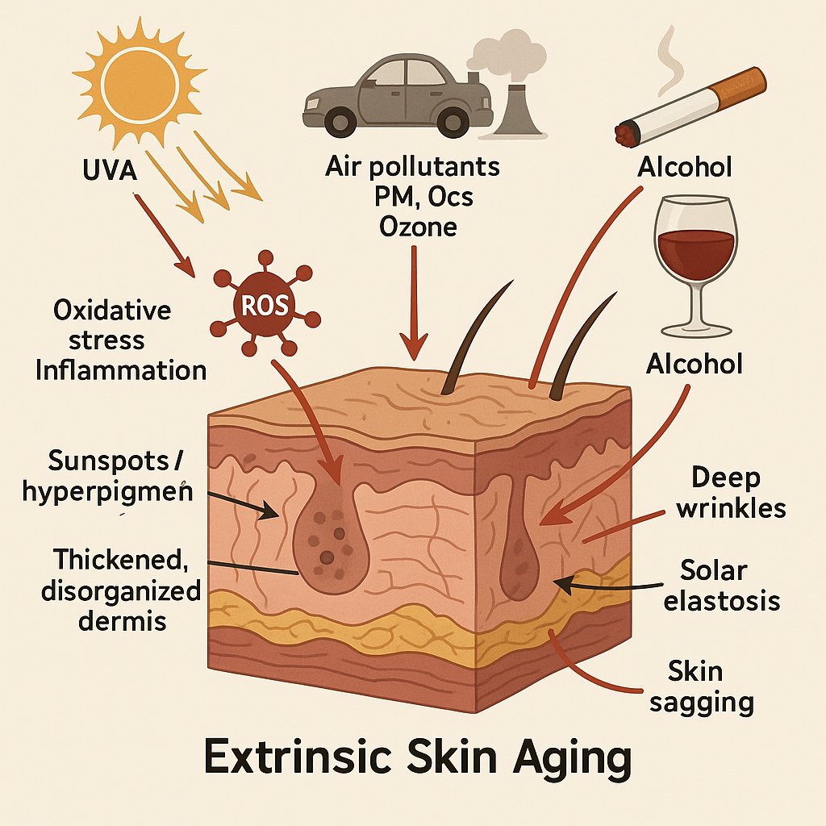

**Figure 2: Illustration of the effects of UV radiation and pollution on the microscopic structure of the skin.**

* Left side–Healthy Skin: Intact and well-organized Type I collagen fibers, along with pliable elastin, maintain skin firmness and elasticity. The tissue appears stable with no signs of inflammation or structural damage.
* Right side–Photoaged Skin: Collagen fibers become fragmented and disorganized, while elastin is altered into thickened, dense clumps (solar elastosis). There is also increased oxidative stress and chronic inflammation, which are hallmarks of prolonged exposure to ultraviolet radiation and environmental pollutants.

### Specific manifestations of facial aging

This project specifically focuses on the precise analysis and quantitative assessment of three critical and highly prevalent visible signs of facial aging: wrinkles, pigmentation spots, and skin dryness. Each of these manifestations arises from distinct underlying cellular and molecular changes, presenting unique visual characteristics that our AI system is engineered to objectively detect, quantify, and score.

The selection of these three key indicators is further substantiated by recent dermatological research utilizing advanced analytical techniques. For instance, a study employing Principal Component Analysis (PCA) to identify the main components of skin aging expression in Asian populations revealed compelling findings [12]. The results indicated that:

* Principal Component 1 (PC1) accounted for 17.36% of the total variance, primarily representing factors related to wrinkles.
* Principal Component 2 (PC2) explained 7.04% of the variance, mainly associated with pigmentation changes.
* Principal Component 3 (PC3), contributing 2.79% of the variance, was linked to skin dryness, moisture loss, and stratum corneum condition.

These findings strongly suggest that wrinkles, pigmentation spots, and skin dryness are distinct, independent, and principal components of facial skin aging. Therefore, by accurately detecting and quantifying these three manifestations, our AI system aims to provide a comprehensive and scientifically grounded assessment of facial aging severity.

#### Wrinkles

Wrinkles represent the quintessential visual hallmark of aging skin, manifesting as linear folds, creases, or ridges on the skin's surface. Their formation is an intricate and cumulative process primarily driven by the progressive degradation and disorganization of the vital collagen and elastin fibers within the dermal extracellular matrix, particularly concentrated in the reticular dermis. This breakdown, often significantly accelerated by the activity of matrix metalloproteinases (MMPs) triggered by chronic extrinsic factors like UV radiation and inflammation, leads to a profound reduction in the skin's inherent elasticity, its tensile strength, and its fundamental ability to recoil and return to its original smooth shape after stretching or muscle contraction. Furthermore, the thinning of the epidermal layer and the flattening of the dermal-epidermal junction contribute to the skin's diminished resilience and structural support, making it more prone to creasing.

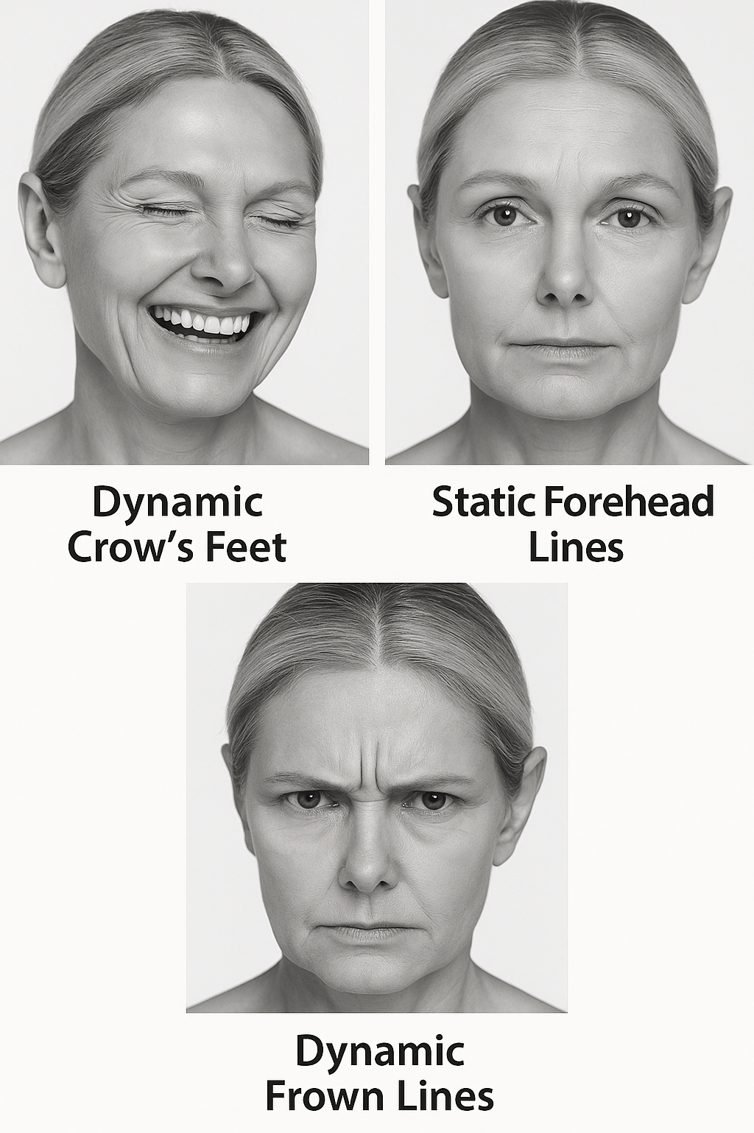

**Figure 3: Illustration of typical facial wrinkle regions categorized by expression and type.**

Wrinkles can be broadly categorized into two main types: dynamic (or expression) wrinkles and static wrinkles. Dynamic wrinkles are temporary, appearing primarily during facial muscle contractions (e.g., crow's feet around the eyes when smiling, frown lines between the eyebrows when furrowing the brow, or forehead lines when raising eyebrows). They are a result of repetitive muscle movements. Conversely, static wrinkles are those that remain persistently visible even when facial muscles are entirely relaxed. Their presence indicates more profound and sustained structural damage to the skin's underlying architecture. For the purpose of objective automated assessment, dermatological scales such as the Wrinkle Severity Rating Scale (WSRS) are widely employed in clinical settings. WSRS classifies wrinkles based on their observed depth, length, and overall prominence, typically assigning a numerical score (e.g., on a scale of 0 to 4, where 0 represents no wrinkles and higher numbers indicate increasingly severe wrinkling).

|  |  |  |
| --- | --- | --- |
| **Score** | **Severity** | **Description** |
| 4 | Extreme | Very deep wrinkle, redundant fold (overlapping skin) |
| 3 | Severe | Deep wrinkle, well-defined edges (but not overlapping) |
| 2 | Moderate | Moderately deep wrinkle |
| 1 | Mild | Shallow, just perceptible wrinkle |
| 0 | None | No wrinkle |

**Table 2: Wrinkle Severity Rating Scale (WSRS)**

As automated systems aim to precisely mimic this clinical grading process. This typically involves an initial step of automatic wrinkle segmentation, which accurately identifies and isolates the wrinkle lines within the facial image. Subsequently, specific quantitative features are extracted from these segmented lines, including their average depth, maximum depth, overall length, and density within predefined facial regions. These precise quantitative features are then meticulously mapped to a severity score, often directly aligning with established clinical scales like WSRS, thereby enabling consistent, repeatable, and objective grading. Visual indicators crucial for AI detection include distinct linear depressions, noticeable changes in light reflectivity along the furrow (which appears as shadows or darker lines), and subtle alterations in the surrounding skin texture immediately adjacent to the wrinkle, often appearing rougher or less uniform.

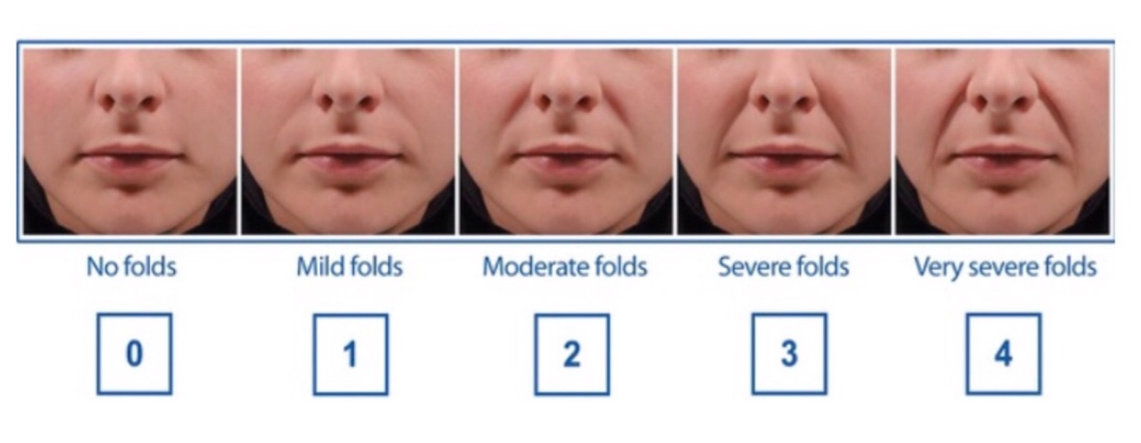

**Figure 4: Illustrated crease sverity scale**

#### Pigmentation spots

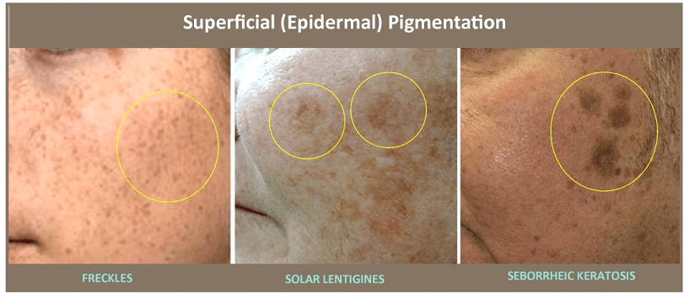Pigmentation spots, collectively referred to as hyperpigmentation or dyschromia, represent another highly prevalent and visibly impactful manifestation of skin aging, whose severity is significantly exacerbated by chronic sun exposure. These spots are characterized by localized areas of increased melanin production and subsequent accumulation, resulting in darker, discolored patches on the skin's surface. The underlying cellular mechanism involves the irregular overactivity of melanocytes, the specialized melanin-producing cells located in the basal layer of the epidermis, and the subsequent irregular transfer of melanosomes (organelles containing melanin) to surrounding keratinocytes. This process is frequently triggered or intensified by chronic UV radiation, post-inflammatory processes (e.g., from acne or injury), or hormonal fluctuations.

**Figure 5:Close-up images of different types of pigmented lesions on facial skin, illustrating clear morphological differences**

Common types of pigmentation spots directly associated with skin aging include solar lentigines (frequently known as age spots, sun spots, or liver spots). These are typically flat, benign, well-demarcated lesions that can range in color from light brown to black. They primarily appear on chronically sun-exposed areas such as the face, hands, shoulders, and décolletage. Another significant dermatological concern, particularly prevalent among women and in populations with darker skin phototypes, is melasma. Melasma manifests as larger, often symmetrical, and irregularly shaped patches of hyperpigmentation, predominantly on the face (e.g., cheeks, forehead, upper lip, chin). Its etiology is strongly linked to hormonal changes (such as those occurring during pregnancy, with oral contraceptive use, or hormone replacement therapy) combined with significant UV exposure. While less directly related to aging, post-inflammatory hyperpigmentation (PIH), which results from the skin's healing response to inflammation or injury, can also contribute to uneven skin tone and tends to persist longer in aging skin due to slower cellular turnover. Automate systems for pigmentation analysis employ sophisticated image processing techniques. This typically involves transforming the image into different color spaces (e.g., RGB to Lab or HSV) to effectively isolate and enhance components related to melanin. Subsequent image segmentation algorithms are then applied to precisely delineate individual spots or areas of discoloration. Quantification involves measuring critical parameters such as the total number of detected spots, their average and cumulative area, the average intensity (darkness) of the pigmentation, and their overall spatial distribution across the facial regions. These comprehensive metrics are then used to derive a precise pigmentation score, accurately reflecting the severity and extent of uneven skin tone.

#### Skin dryness

Skin dryness, clinically referred to as xerosis cutis or anhidrosis, becomes increasingly prevalent and pronounced with advancing age, serving as a significant indicator of compromised skin barrier function and diminished overall skin health. The aging process inherently leads to several physiological changes that predispose the skin to reduced hydration. These include a natural reduction in the production of natural moisturizing factors (NMFs) within the stratum corneum (the outermost layer of the epidermis), a decline in sebaceous gland activity leading to decreased sebum (skin's natural oils) secretion, and a general weakening and disorganization of the epidermal lipid barrier. These physiological alterations collectively result in an increased transepidermal water loss (TEWL) – the insensible diffusion of water through the skin – and a reduced capacity of the stratum corneum to retain adequate intrinsic hydration. This physiological imbalance directly manifests in the characteristic symptoms of dry, rough, and sometimes flaky or scaly skin.

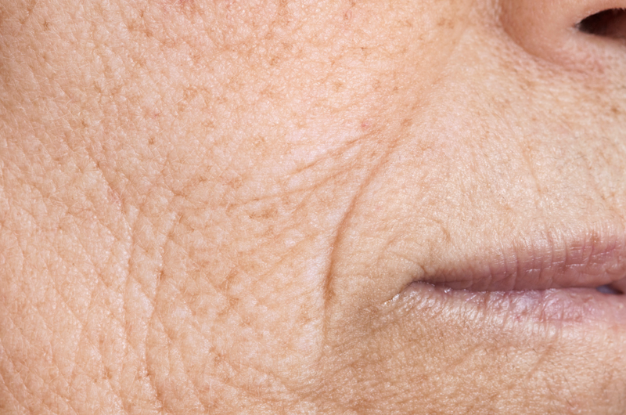

**Figure 6: Dry skin due to aging**

Visually, dry skin typically presents as dull, lacking the healthy radiance and plumpness associated with well-hydrated skin. It may exhibit a rough, uneven texture upon tactile inspection, and paradoxically, fine lines and superficial wrinkles can appear more pronounced or etched due to the lack of skin turgor and hydration. In more severe cases, visible scaling, superficial flakiness (desquamation), and even microscopic cracks or fissures may be present on the skin surface, which can lead to discomfort, itching, and increased susceptibility to environmental irritants and microbial invasion. While objective assessment of skin hydration in a clinical setting often employs specialized biophysical instruments like corneometers (which measure skin capacitance or electrical conductivity to infer hydration levels), AI-based image analysis relies on interpreting subtle yet discernible visual cues from high-resolution photographs. Computer vision algorithms can analyze complex image texture patterns, meticulously quantifying characteristics such as roughness, unevenness, or the presence of microscopic scaling. They also assess statistical properties of pixel intensity variations that indicate dullness or the absence of a healthy glow, and detect subtle changes in light reflectivity across the skin surface which correlate with hydration levels. These advanced image analyses allow for an inference or scoring of skin dryness levels, contributing a crucial and distinct component to the holistic facial aging assessment.

## Artificial intelligence and computer vision in dermatological analysis

This section provides a comprehensive overview of the theoretical foundations of artificial intelligence (AI) and computer vision, with a specific focus on their applications in skin analysis, particularly for assessing facial aging and supporting dermatological diagnostics. It also reviews related work on AI-based systems for facial aging assessment, other skin condition diagnostics, and skincare product recommendation, highlighting the state-of-the-art and gaps addressed by this project.

### Introduction to artificial intelligence and machine learning

Artificial Intelligence (AI) encompasses computational systems designed to perform tasks that typically require human intelligence, such as pattern recognition, decision-making, and problem-solving. Within AI, Machine Learning (ML) is a pivotal subset that enables systems to learn from data and improve performance without explicit programming. ML algorithms are broadly categorized into supervised learning (using labeled data for tasks like classification and regression), unsupervised learning (identifying patterns in unlabeled data, e.g., clustering), and reinforcement learning (learning through trial and error).

In dermatological applications, supervised learning is predominant due to the availability of annotated datasets, such as images labeled with skin conditions or aging signs. For instance, classification models predict specific skin concerns (e.g., wrinkles, pigmentation), while regression models estimate continuous values like aging severity scores. ML's ability to process large datasets and identify complex patterns makes it ideal for analyzing facial images, where subtle visual cues indicate aging or skin health.

### Deep learning and Convolutional Neural Networks (CNNs)

Deep Learning (DL), a specialized branch of ML, leverages neural networks with multiple layers to model complex, non-linear relationships in data. Convolutional Neural Networks (CNNs) are particularly effective for image-based tasks, such as facial skin analysis, due to their ability to extract hierarchical features from raw pixel data. CNNs consist of convolutional layers (applying filters to detect features like edges or textures), pooling layers (reducing spatial dimensions while preserving important information), and fully connected layers (integrating features for classification or regression).

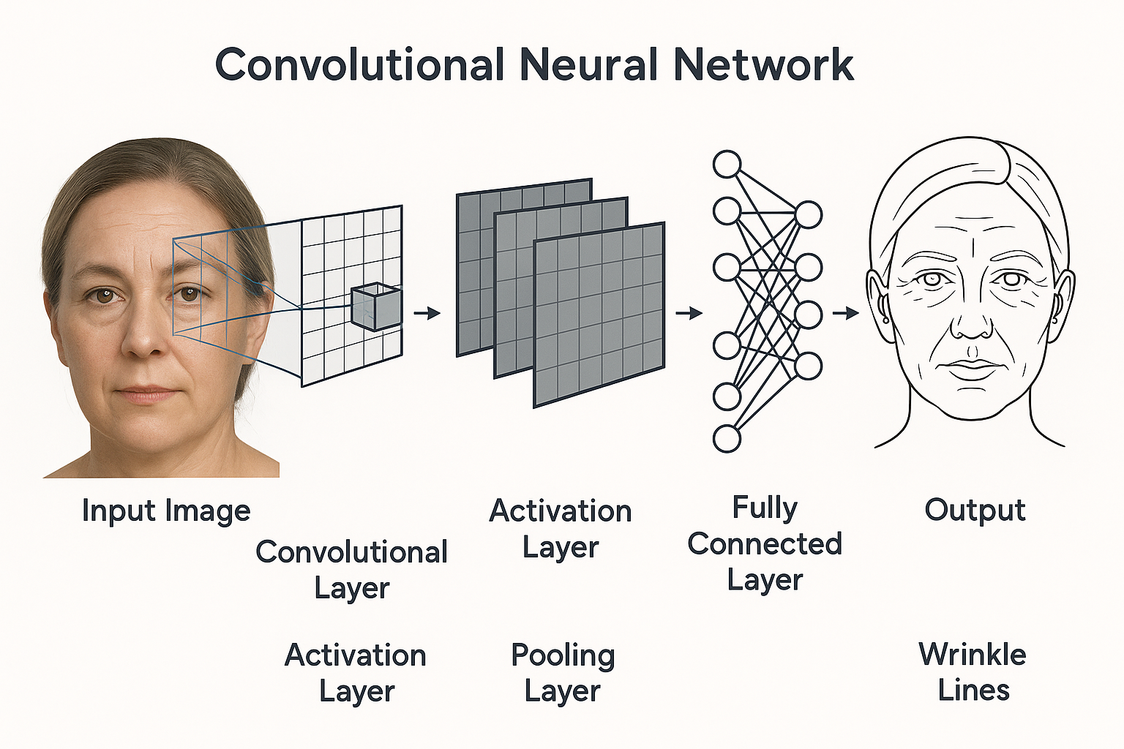

**Figure 7: Illustration of a Convolutional Neural Network (CNN) architecture used for facial skin analysis.**

* Convolutional Layer: This is the core building block of a CNN. It applies a series of learnable filters (or kernels) to the input image. Each filter slides across the image, performing a convolution operation to create a feature map that highlights specific patterns, edges, textures, or shapes within the image. Different filters can detect different features. For skin analysis, early layers might detect basic edges or color gradients, while deeper layers learn to recognize more complex patterns like wrinkle lines, the texture of dry skin, or the specific appearance of pigmentation spots.
* Activation Layer (e.g., ReLU - Rectified Linear Unit): Applied after each convolutional layer, activation functions introduce non-linearity into the model. ReLU, with its simple f(x) = max(0, x) function, is commonly used because it helps the network learn complex relationships and speeds up training by addressing vanishing gradient problems.
* Pooling Layer (e.g., Max Pooling, Average Pooling): These layers are typically inserted between successive convolutional layers. Their primary role is to reduce the spatial dimensions (width and height) of the feature maps, thereby decreasing the number of parameters and computations in the network and controlling overfitting. Pooling extracts the most salient features from regions, making the model more robust to minor shifts or distortions in the input image.
* Fully Connected Layer (Dense Layer): After several convolutional and pooling layers, the extracted high-level features are flattened into a single vector and fed into one or more fully connected layers. Each neuron in these layers is connected to every neuron in the previous layer, similar to a traditional neural network. These layers are responsible for performing the final classification or regression based on the features learned by the preceding layers. For skin aging diagnosis, this layer would output the probability of specific aging signs or their severity scores.

In skin analysis, CNNs excel at detecting and quantifying aging signs like wrinkles, pigmentation spots, and skin dryness. For example, early layers identify low-level features (e.g., lines or color variations), while deeper layers capture high-level patterns (e.g., wrinkle density or pigmentation distribution). Advanced architectures, such as U-Net for segmentation or ResNet for classification, enhance performance by addressing challenges like vanishing gradients or overfitting. Multi-task learning frameworks, where a single CNN simultaneously predicts multiple aging indicators, further improve efficiency and accuracy.

### Image preprocessing techniques

Effective skin analysis relies on robust image preprocessing to ensure consistent and high-quality input for AI models. Common preprocessing steps include:

* **Facial detection and alignment**: Algorithms like Multi-task Cascaded Convolutional Networks (MTCNN) or Single Shot Detector (SSD) detect facial landmarks and align images to a standardized template, mitigating variations in pose or scale.

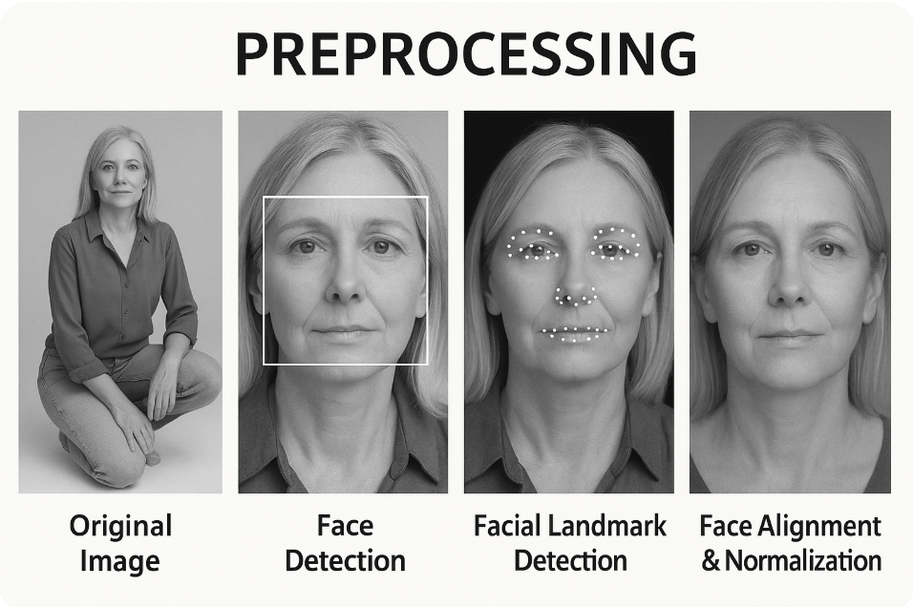

**Figure 8: Preprocessing steps in facial image analysis for skin assessment**

* **Illumination normalization**: Techniques such as Contrast Limited Adaptive Histogram Equalization (CLAHE) or histogram equalization adjust lighting conditions to enhance feature visibility, crucial for detecting subtle aging signs.
* **Color space transformation**: Converting images from RGB to HSV or Lab color spaces isolates skin-specific features (e.g., pigmentation intensity) from lighting artifacts.

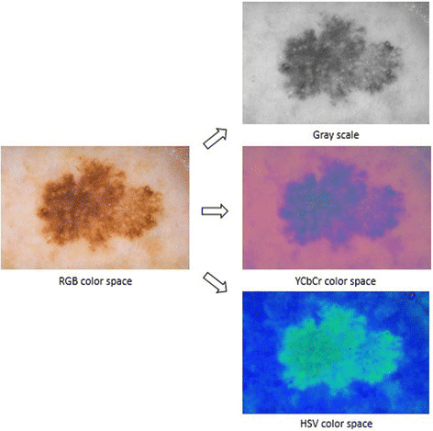

**Figure 9: Different color space transformations of a RGB image**

* **Region-of-Interest extraction**: Masking non-facial areas (e.g., hair, background) focuses analysis on relevant skin regions.

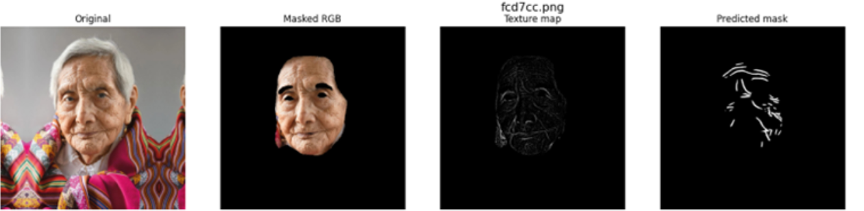

**Figure 10: Region-of-interest extraction from facial image**

* **Data augmentation**: Techniques like flipping, rotation, or brightness adjustment increase dataset diversity, improving model robustness against real-world variations.

### AI-Based facial aging assessment systems

Recent research has leveraged AI and computer vision to develop automated systems for facial aging assessment, focusing on objective quantification of aging signs. Notable studies include:

* **Wrinkle detection**: Batool and Chellappa (2015) proposed a Markov random field approach to model the spatio-temporal evolution of wrinkles, achieving robust detection across dynamic expressions [20]. Ng et al. (2018) introduced a hybrid Hessian filter for automatic wrinkle detection, improving accuracy on diverse datasets [21]. Cula et al. (2013) developed methods for automatic wrinkle quantification, correlating results with clinical assessments [23].
* **Age estimation**: Liu et al. (2017) employed ordinal deep learning for facial age estimation, achieving high accuracy by modeling age as an ordered sequence [24]. Antipov et al. (2017) combined general and children-specialized CNNs for apparent age estimation, addressing age-specific feature variations [26]. Zou et al. (2020) focused on robust age estimation from noisy images, critical for real-world applications [22].
* **Multi-Task frameworks**: Ranjan et al. (2017) proposed HyperFace, a deep multi-task learning framework for simultaneous face detection, landmark localization, and age estimation, demonstrating the efficiency of integrated models [25].

These studies highlight CNNs' effectiveness in detecting wrinkles, estimating age, and segmenting aging signs. However, challenges remain, such as limited dataset diversity (e.g., underrepresentation of Asian skin types) and sensitivity to environmental factors like lighting or makeup. This project addresses these gaps by incorporating Asian-specific datasets and robust preprocessing pipelines.

### Skincare product recommendation systems

AI-driven recommendation systems have transformed personalized skincare by matching products to individual needs. Ricci et al. (2015) outlined content-based and collaborative filtering techniques, where content-based methods match product attributes (e.g., ingredients) to user profiles, and collaborative filtering leverages user behavior patterns [27]. Koren et al. (2009) introduced matrix factorization for collaborative filtering, improving recommendation accuracy [28]. Adomavicius and Tuzhilin (2005) surveyed next-generation recommendation systems, emphasizing hybrid approaches combining content and collaborative methods [29].

The proliferation of e-commerce and personalized consumer experiences has driven significant research and development in recommendation systems across various industries, including beauty and skincare. These systems aim to suggest items (products, services, content) to users that are likely to be of interest, based on their preferences and past behavior. Generally, recommendation systems can be categorized into a few main types:

* Content-Based Filtering: This approach recommends items that are similar to items the user has liked in the past. In the context of skincare, if a user has shown interest in products containing hyaluronic acid for hydration, a content-based system would recommend other products with similar ingredients or benefits. This method is particularly relevant to our project, as recommendations will be directly tied to the specific "content" of the user's skin analysis (i.e., detected wrinkles, pigmentation, dryness) and the "content" (ingredients, claims, benefits) of skincare products.
* Collaborative Filtering: This broad category of methods makes recommendations based on the preferences and behaviors of users or the characteristics of items. It typically has two main sub-approaches:
  + User-Based Collaborative Filtering: This traditional approach makes recommendations based on the preferences of other users who have similar tastes or behaviors. For example, if User A and User B have similar preferences for a set of skincare products, and User A likes a product that User B has not yet tried, that product might be recommended to User B.
  + Item-Based Collaborative Filtering: Instead of finding similar users, this method identifies relationships between items. It recommends items that are similar to items the user has already liked, where "similarity" is determined by the preferences of many users. For instance, if users who bought "Product X (a moisturizer)" also frequently bought "Product Y (a serum)", then if a new user buys "Product X", "Product Y" might be recommended. This approach is highly effective in scenarios with a large number of items and can be computationally more efficient than user-based methods for very large user bases. In our skincare context, if products often used together or rated similarly for certain skin concerns (e.g., a specific cleanser and a matching toner for oily skin) are identified as "similar items", the system could leverage this for recommendations. This method requires a robust dataset of user-item interactions and product co-occurrences.
* Hybrid Systems: Many modern recommendation systems combine elements of both content-based and collaborative filtering to leverage their respective strengths and mitigate individual weaknesses, often resulting in more robust and accurate recommendations.

In the beauty and skincare industry, existing recommendation systems often rely on user-input questionnaires (e.g., asking about skin type, concerns), historical purchase data, or general popularity. While these methods offer some level of personalization, they frequently lack the objective, detailed diagnostic input that an AI-based skin analysis can provide. For instance, a user might perceive their skin as dry, but a precise AI analysis might reveal that their primary concern is actually dehydration-induced fine lines rather than true xerosis, leading to more targeted recommendations. The integration of advanced visual AI diagnostics with a recommendation engine is a key area of innovation that this project seeks to address, moving beyond generic recommendations to truly personalized, data-driven solutions directly addressing specific and quantified skin concerns.

# PROPOSED METHODS

## System architecture overview

The proposed AI-integrated system for facial aging assessment and personalized skincare recommendation employs a comprehensive modular architecture designed to ensure scalability, maintainability, and optimal performance. The system architecture comprises four primary interconnected modules that collectively address the complex requirements of automated facial aging analysis and intelligent product recommendations.

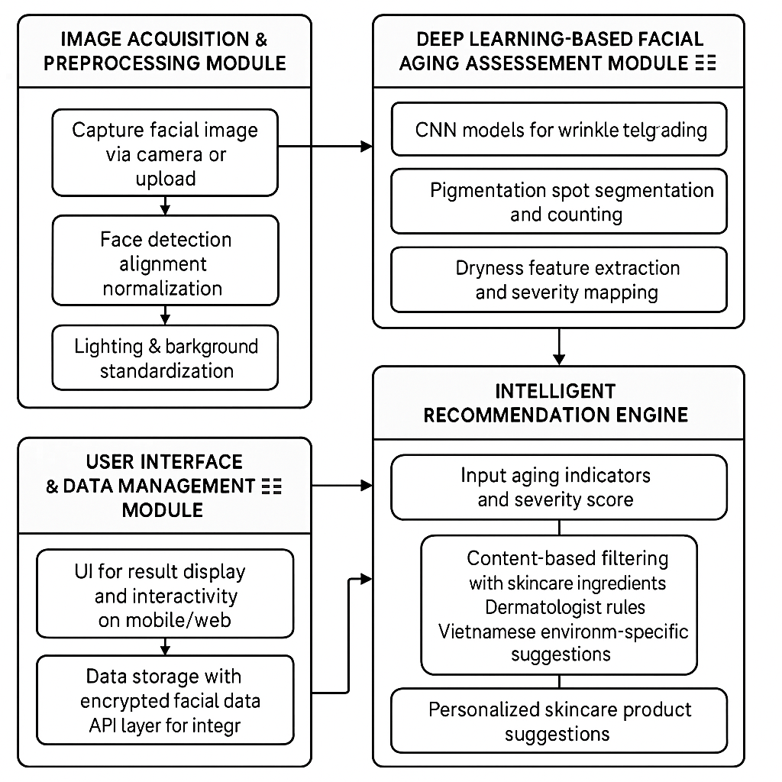

**Figure 11: System architecture overview diagram**

* The Image Acquisition and Preprocessing Module serves as the foundational component, responsible for capturing and standardizing facial images to ensure consistent input quality for subsequent analysis. This module implements advanced computer vision techniques to detect, align, and normalize facial regions while mitigating variations in lighting conditions, pose orientations, and background interference that commonly occur in real-world image capture scenarios.
* The Deep Learning-Based Facial Aging Assessment Module constitutes the core analytical component of the system, employing sophisticated Convolutional Neural Networks (CNNs) to quantitatively evaluate three critical aging indicators: wrinkles, pigmentation spots, and skin dryness. This module is engineered to provide objective, reproducible severity assessments for each aging sign while synthesizing these individual evaluations into a comprehensive overall aging severity score.
* The Intelligent Recommendation Engine leverages the output from the aging assessment module to generate personalized skincare product suggestions. This module employs content-based filtering algorithms enhanced with dermatological expertise and market-specific considerations tailored to Vietnamese consumers' needs and environmental factors.
* The User Interface and Data Management Module facilitates seamless user interaction while ensuring secure data handling, result visualization, and system integration. This module incorporates responsive design principles to accommodate various device types and implements robust data privacy protocols to protect sensitive facial image data.

## Model architecture

This study evaluates the effectiveness of the proposed two-stage training strategy using two deep neural network architectures commonly employed in medical image segmentation: U-Net and Swin UNETR.

U-Net is a convolutional neural network (CNN) architecture with a symmetrical encoder–decoder structure, widely used for biomedical image segmentation tasks [[1](https://arxiv.org/abs/2408.10060)2]. The architecture consists of:

* Four encoder blocks for hierarchical feature extraction, employing convolutional, normalization, and downsampling layers.
* Four decoder blocks that perform upsampling and convolution operations to reconstruct the spatial resolution of the input image.
* Skip connections between corresponding encoder and decoder blocks, which preserve spatial detail and mitigate the loss of fine-grained features.

U-Net serves as the baseline model for the comparative experiments and ablation studies in this work.

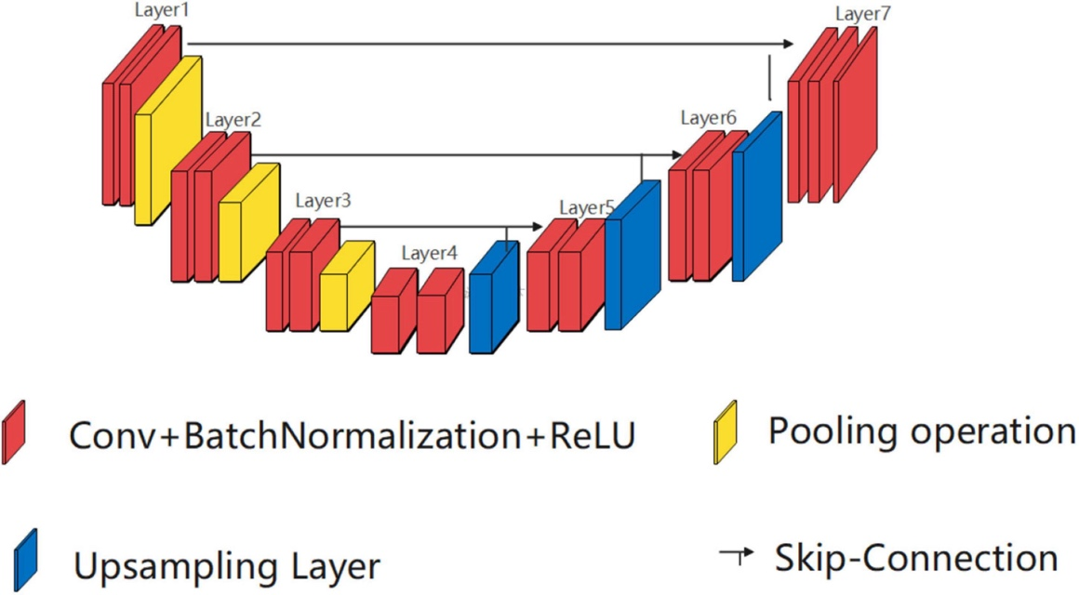

**Figure 12: Structure diagram of UNet.**

Swin UNETR is a hybrid Transformer–CNN architecture that integrates the Swin Transformer as the encoder within the UNETR framework [[13](https://ieeexplore.ieee.org/document/9707078)]. The model features include:

* An encoder built using Swin Transformer blocks with a window size of 16, dividing the image into 4×4 patches, and projecting each patch into a 48-dimensional embedding space.
* Each encoder block comprises two consecutive Swin Transformer blocks.
* The decoder mirrors the U-Net structure, employing upsampling and convolutional layers, combined with skip connections to corresponding encoder layers for feature fusion.

Given the nature of wrinkle segmentation, which requires capturing fine-grained local textures, the CNN-based U-Net demonstrates superior performance due to its strong inductive bias toward local spatial features. Although Swin UNETR possesses the capacity to model global contextual relationships via attention mechanisms, its effectiveness is limited when trained on relatively small annotated datasets, as transformers typically require large-scale data to generalize well [[1](https://arxiv.org/abs/2408.10060)2].

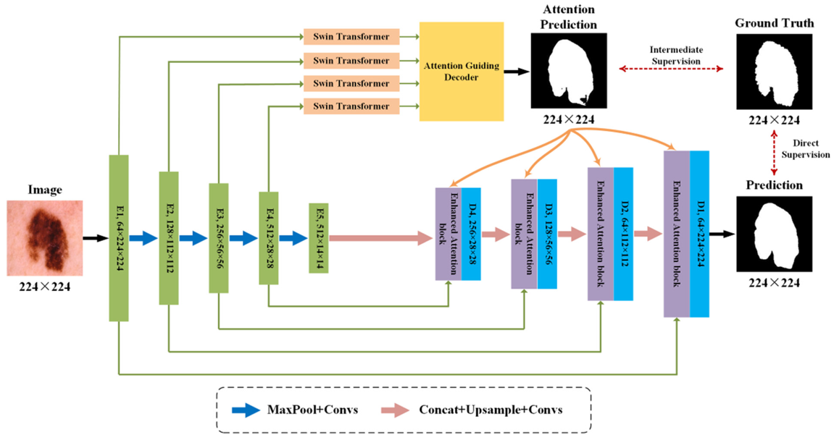

**Figure 13: The illustration of the proposed Swin-PANet in the task of skin lesion segmentation [31]**

Nevertheless, Swin UNETR shows progressive performance improvements under the proposed training strategy, suggesting strong potential for further enhancement with extended pretraining or larger datasets. Overall, U-Net remains advantageous in scenarios with limited supervision, while Swin UNETR holds promise for scalability in data-rich environments [[1](https://arxiv.org/abs/2408.10060)2].

## Aging indicator detection and assessment methods

### Wrinkle detection and severity assessment

The wrinkle detection methodology combines traditional computer vision techniques with deep learning approaches to achieve robust and accurate wrinkle identification and severity assessment. The system employs a two-stage training strategy leveraging both weak supervision and manual annotations.

Technical Features for Wrinkle Detection [[12](https://arxiv.org/abs/2408.10060)]:

* Edge Contrast Analysis: Analyzes sudden changes in pixel intensity creating curved or straight lines with random orientations
* Texture Pattern Recognition: Identifies characteristic patterns through gradient magnitude variations and surface structure differences

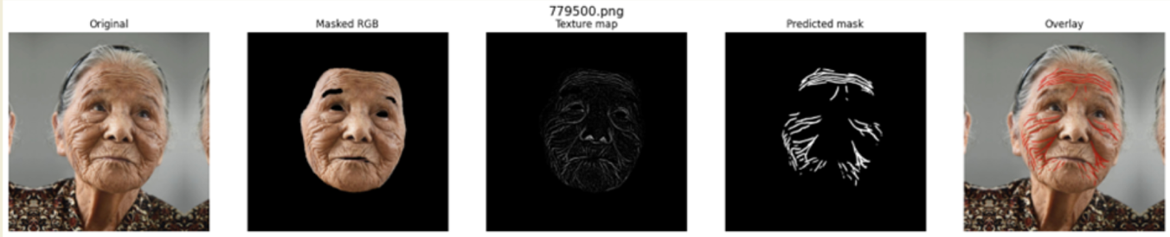

**Figure 14: Stages of facial wrinkle detection using a deep learning pipeline.**

Severity Assessment Scale: The system implements the Wrinkle Severity Rating Scale (WSRS) with five levels [[14](https://pubmed.ncbi.nlm.nih.gov/14979743/)]:

* *Grade 0: No visible wrinkles, smooth skin surface.*
* *Grade 1: Shallow wrinkles, only visible under angled lighting.*
* *Grade 2: Moderate wrinkles, visible at rest with moderate depth.*
* *Grade 3: Deep wrinkles, clearly visible at rest, affecting facial structure.*
* *Grade 4: Very deep wrinkles, forming large grooves with significant aesthetic.*

Quantitative Metrics: The system calculates multiple quantitative measures [[15](https://pubmed.ncbi.nlm.nih.gov/15036275/)]:

* Wrinkle area percentage relative to facial region
* Average depth estimation through pixel intensity analysis
* Wrinkle density through texture analysis complexity
* Total wrinkle length measurement within facial regions

Proposer the Wrinkle Severity Rating Score:

* Wrinkle Area Ratio (wrinkle_ratio): Proportion of wrinkle pixels over the total face skin pixels. Formula: wrinkle_pixels / total_pixels
* Wrinkle Depth (depth_factor): Average texture intensity within wrinkle regions, normalized to [0, 1].
* Wrinkle Density: Number of detected wrinkle clusters per unit area of facial skin.
* Wrinkle Length: Total length of wrinkle contours detected across the face.

|  |  |  |  |  |  |
| --- | --- | --- | --- | --- | --- |
| **Grade** | **Area** | **Depth** | **Density** | **Length** | **Clinical Description** |
| 0 | < 0.5% | < 1.5% | < 2 line | < 30 px ≈ 3mm | No clearly visible wrinkles |
| 1 | ≥ 0.5% | ≥ 1.5% | ≥ 2 line | ≥ 30 px ≈ 3mm | Fine, small wrinkles |
| 2 | ≥ 2% | ≥ 3% | ≥ 5 line | ≥ 100 px ≈ 10mm | Visible, moderate wrinkles |
| 3 | ≥ 4.5% | ≥ 5% | ≥ 12 line | ≥ 300 px ≈ 30mm | Deep wrinkles affecting facial contour |
| 4 | ≥ 7% | ≥ 7% | ≥ 20 line | ≥ 500 px ≈ 50mm | Deep wrinkles affecting facial contour |

**Table 3: Wrinkle severity grading scale based on a composite score combining quantitative metrics such as wrinkle area, depth, density, and length**

### Pigmentation spot detection and classification

The pigmentation assessment methodology focuses on detecting and quantifying melanin-related discoloration and age spots across facial regions. The system employs sophisticated color space analysis and segmentation techniques.

Technical Approach :

* Color Space Analysis: Utilizes RGB to Lab color space conversion for lighting-independent assessment [[16](https://onlinelibrary.wiley.com/doi/10.1111/srt.13216)].
* Segmentation Techniques: Implements thresholding in HSV color space, Watershed Algorithm for clear boundary detection, and deep learning-based segmentation using U-Net and Mask R-CNN architectures [[16](https://onlinelibrary.wiley.com/doi/10.1111/srt.13216)].

Assessment Criteria [[17](https://www.nature.com/articles/s41746-023-00881-0)]:

* Spot Count: Automated counting of detected pigmentation regions
* Size Analysis: Area measurement using OpenCV contour analysis with mm² conversion
* Color Intensity: Lab color space a and b channel analysis for pigmentation darkness assessment
* Location Mapping: Facial landmark-based position analysis for aesthetic impact evaluation

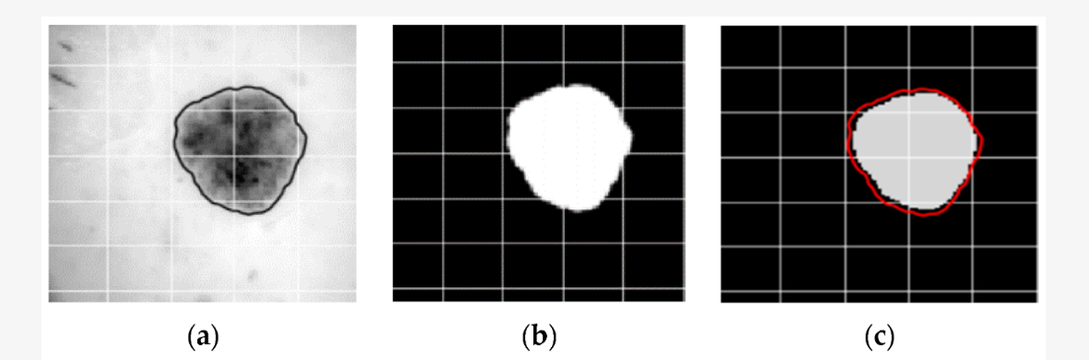

**Figure 15: Sample results of segmented skin lesion: (a) original image (black line is the ground truth); (b) ground truth; (c) result of U-Net;**

Proposer the Severity Scale (0-4):

* Grade 0: Even skin tone, no pigmentation spots
* Grade 1: Slight uneven pigmentation, few brown/mole spots
* Grade 2: Several visible brown/mole spots
* Grade 3: Multiple brown/mole spots, uneven distribution
* Grade 4: Numerous brown/mole spots, large size and wide distribution

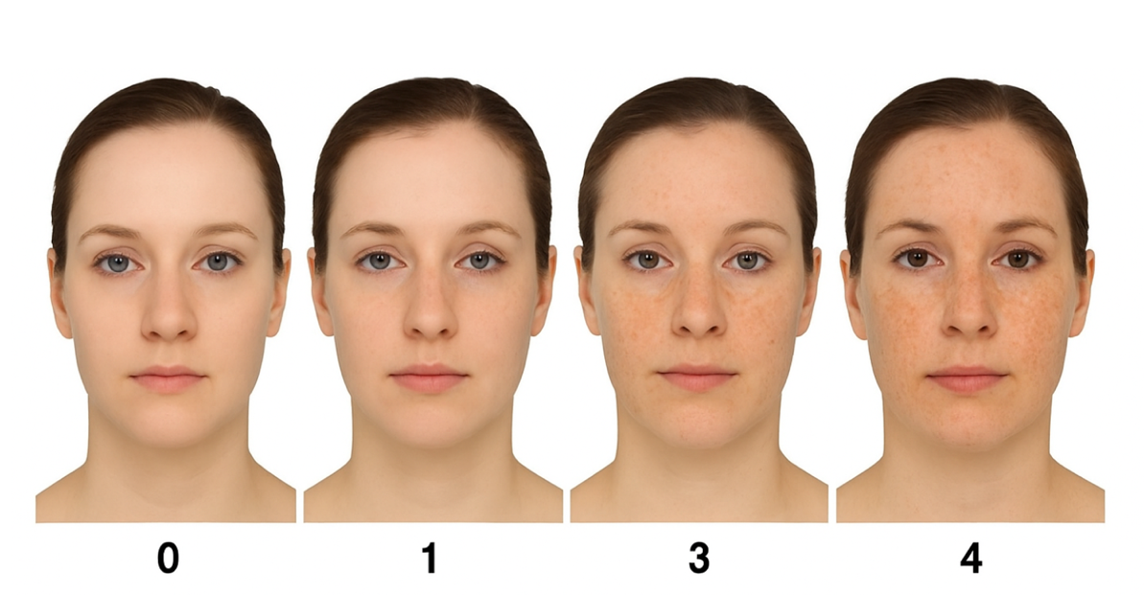

**Figure 16: A grading scale illustrating different levels of facial pigmentation, from Grade 0 to Grade 4**

|  |  |  |  |  |  |
| --- | --- | --- | --- | --- | --- |
| Level | Description | Spot Count | Spot Size (mm²) | Intensity | Coverage (%) |
| 0 | None | 0 | 0 | 0 | 0 |
| 1 | Mild | 1–5 | <2 | <0.3 | <0.5 |
| 2 | Moderate | 6–20 | 2–5 | 0.3–0.5 | 0.5–2 |
| 3 | Severe | 21–50 | 5–10 | 0.5–0.7 | 2–5 |
| 4 | Very Severe | >50 | >10 | >0.7 | >5 |

**Table 4: Pigmentation severity grading scale based on five levels (0 to 4)**

### Skin dryness evaluation and measurement

The skin dryness assessment methodology addresses the detection of moisture-related skin characteristics through advanced texture analysis and surface pattern recognition. Technical Implementation [[18](https://www.nature.com/articles/srep02190?utm_source=chatgpt.com)]:

* Texture Analysis: Employs Haralick Texture Features for roughness, contrast, and entropy measurement
* Surface Pattern Detection: Uses Local Binary Patterns (LBP) and Gabor Filters for texture characterization
* Flaking Detection: Implements connected component analysis for identifying scaling areas

Quantitative Measures [[19](https://www.researchgate.net/publication/39290434_Use_of_Gabor_Filters_for_texture_classification_of_digital_images)]:

* Texture Roughness: Entropy and contrast measurements from Haralick features
* Flaking Area: Pixel area calculation with mm² conversion based on image resolution
* Surface Brightness: Analysis of relative brightness variations indicating dry patches

Severity Assessment (0-4):

* Grade 0: No flaking, roughness <0.2, relative brightness <5
* Grade 1: <5 flaking areas, area <0.5 mm², roughness 0.2-0.4, brightness 5-10
* Grade 2: 5-20 areas, area 0.5-2 mm², roughness 0.4-0.6, brightness 10-20
* Grade 3: 21-50 areas, area 2-5 mm², roughness 0.6-0.8, brightness 20-30
* Grade 4: >50 areas, area >5 mm², roughness >0.8, brightness >30

Proposer the Dryness severity scale (0-4):

|  |  |  |  |  |  |
| --- | --- | --- | --- | --- | --- |
| **Level** | **Description** | **Flaking Spots** | **Flaking Area (mm²)** | **Roughness** | **Brightness Variation** |
| 0 | Normal | 0 | 0 | <0.2 | <8 |
| 1 | Slightly Dry | 1–3 | <0.3 | 0.2–0.4 | 8–15 |
| 2 | Moderately Dry | 4–10 | 0.3–1 | 0.4–0.6 | 15–25 |
| 3 | Severely Dry | 11–25 | 1–3 | 0.6–0.8 | 25–35 |
| 4 | Very Severely Dry | >25 | >3 | >0.8 | >35 |

**Table 5: Dryness severity scale ranging from Level 0 to Level 4, defined by measurable features including number of flaking spots, flaking area (mm²), surface roughness, and brightness variation.**

## Overall facial aging assessment methodology

This study proposes and implements an Ordinal Regression model using the Cumulative Link Model approach to assess skin aging levels based on three key features: Wrinkle Score, Pigment Score, and Dryness Score. The model achieves 88.68% classification accuracy with a Mean Absolute Error of only 0.1132, demonstrating high effectiveness in hierarchical classification of skin aging levels.

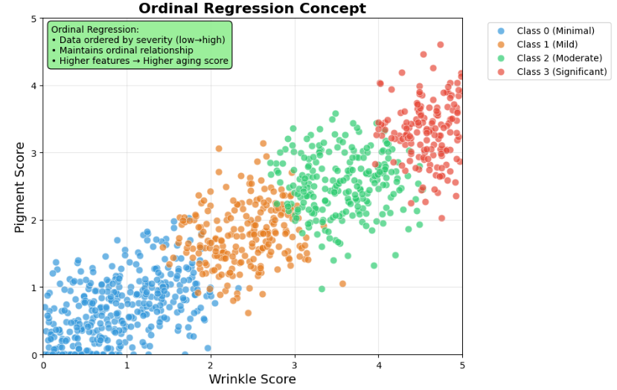

**Figure 17: Ordinal regression concept**

Develop a machine learning model to automatically assess skin aging levels on a scale from 0 to 4, based on three quantitative indicators:

* **Wrinkle Score**: Wrinkle severity measurement
* **Pigment Score**: Pigmentation assessment
* **Dryness Score**: Skin dryness evaluation

We employ **Ordinal Regression with Cumulative Link Model** instead of standard classification because:

* Respects the ordinal nature of the data
* Handles ordered relationships between classes effectively
* Provides meaningful prediction probabilities

|  |
| --- |
| Input Features → Standardization → Multiple Binary Classifiers → Cumulative Probabilities → Final Prediction |

Uses K-1 binary classifiers for K classes. Each classifier predicts P(Y > threshold_i). Converts cumulative probabilities to class probabilities. For K ordered classes (0, 1, 2, 3, 4):

* P(Y = k) = P(Y > k-1) - P(Y > k)
* For k = 0: P(Y = 0) = P(Y > -1) - P(Y > 0) = 1 - P(Y > 0)

## Skincare product recommendation system

### Content-Based filtering algorithm

The recommendation system employs a sophisticated content-based filtering approach that matches user skin conditions with appropriate skincare ingredients and products. This methodology was selected for its effectiveness with limited user interaction data and its ability to provide explainable recommendations based on dermatological principles.

Algorithm Framework:

* User profile creation: Generate user vectors based on aging assessment results
* Ingredient feature extraction: Map skincare ingredients to their therapeutic properties
* Similarity calculation: Employ cosine similarity for matching user needs with product capabilities
* Recommendation generation: Rank and filter products based on similarity scores

### Ingredient-to-problem mapping

The system maintains a comprehensive database mapping skincare ingredients to their efficacy against specific aging indicators:

Wrinkle Treatment Ingredients:

* Retinol: [Wrinkle reduction: 1.0, Pigmentation: 0.3, Dryness: 0.0]
* Collagen: [Wrinkle reduction: 0.9, Pigmentation: 0.2, Dryness: 0.4]
* Peptides: [Wrinkle reduction: 0.8, Pigmentation: 0.1, Dryness: 0.3]

Pigmentation Treatment Ingredients:

* Vitamin C: [Wrinkle reduction: 0.2, Pigmentation: 1.0, Dryness: 0.0]
* Kojic Acid: [Wrinkle reduction: 0.0, Pigmentation: 0.9, Dryness: 0.1]
* Arbutin: [Wrinkle reduction: 0.1, Pigmentation: 0.8, Dryness: 0.2]

Dryness Treatment Ingredients:

* Hyaluronic Acid: [Wrinkle reduction: 0.0, Pigmentation: 0.0, Dryness: 1.0]
* Glycerin: [Wrinkle reduction: 0.0, Pigmentation: 0.0, Dryness: 0.9]
* Ceramides: [Wrinkle reduction: 0.2, Pigmentation: 0.1, Dryness: 0.8]

### Cosine similarity implementation

The recommendation algorithm calculates similarity between user profiles and product characteristics using the cosine similarity formula:

|  |
| --- |
| Cosine Similarity = (A · B) / (||A|| ||B||) |

Where A represents the user profile vector and B represents the product ingredient vector. Values closer to 1 indicate higher compatibility between user needs and product benefits.

Example Calculation:

* User Profile: [0.8, 0.3, 0.5] (high wrinkles, moderate pigmentation, medium dryness)
* Retinol Product: [1.0, 0.3, 0.0] → High similarity for wrinkle concerns
* Hyaluronic Acid Product: [0.0, 0.0, 1.0] → Lower overall similarity

### Product database integration

The system integrates with a comprehensive product database containing:

* Product Information: Names, brands, ingredient lists, concentrations
* Ingredient Properties: Efficacy ratings, compatibility matrices, usage guidelines
* User Constraints: Budget considerations, brand preferences, ingredient sensitivities

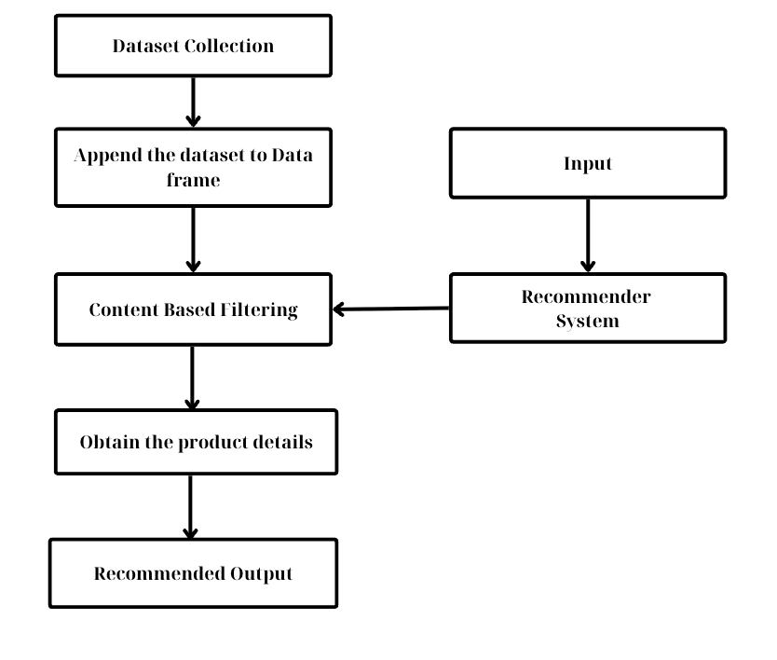

**Figure 18: Overall system architecture of the skincare products recommendation.**

The recommendation engine filters and ranks products based on similarity scores while considering user-specified constraints and preferences, ensuring personalized and practical skincare recommendations.

## System implementation and deployment architecture

### Backend infrastructure

The system backend utilizes a microservices architecture implemented in Python, leveraging specialized frameworks for different components:

* Deep Learning Models: TensorFlow and PyTorch for model training and inference
* Computer Vision Pipeline: OpenCV, Dlib, and MediaPipe for image processing
* Recommendation Engine: Scikit-learn for machine learning algorithms and pandas for data manipulation
* API Framework: FastAPI for high-performance REST API implementation



**Figure 19: Django Rest Framework**

### Scalability and performance optimization

The architecture implements several optimization strategies:

* Containerization: Docker containers ensure consistent deployment across environments
* Load Balancing: Kubernetes orchestration enables automatic scaling based on demand
* GPU Acceleration: CUDA-optimized inference for deep learning model execution
* Caching Strategies: Multi-level caching for API responses and model predictions

### Application interface

#### Information entry page



**Figure 20: User information input interface in the facial skin analysis application**

The screen displays a basic form that collects user details, including:

* Age: A numeric input field for entering the user's age.
* Gender: A dropdown menu for selecting the user's gender.

#### Skin analysis guide page



**Figure 21: Skin scan preparation instruction screen**

This interface presents important guidelines for users to follow before capturing a facial image for skin analysis. The instructions include proper camera distance (30–50 cm), adequate lighting, neutral facial expression, and ensuring no obstructions or other people are in the frame.

#### Face scanning page

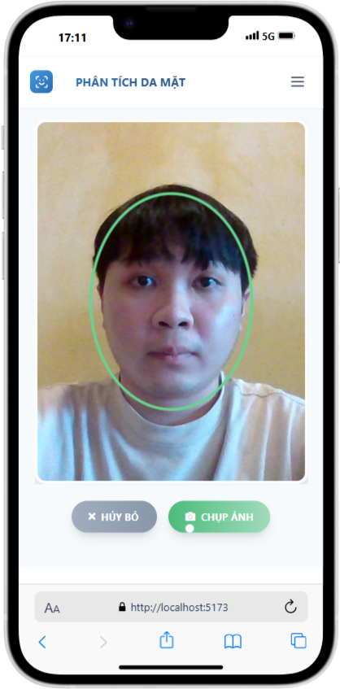

**Figure 22: Face capture screen during skin scanning process**

The user aligns their face within a predefined frame (green oval) to ensure proper positioning and distance, allowing the AI system to capture a high-quality image for accurate analysis.

#### Analysis results page



**Figure 23: Analysis results and overview evaluation screen**

The interface displays the original captured image along with analysis tabs for individual skin features such as wrinkles, pigmentation, and moisture. Below is a general evaluation of the current skin condition, with options for re-analysis or receiving personalized skincare recommendations.



**Figure 24:Wrinkle analysis screen**

The interface shows wrinkle analysis results using the Wrinkle Severity Rating Scale (WSRS). The user's photo is presented alongside detailed assessment of wrinkles in areas such as the corners of the eyes, forehead, and nasolabial folds. Below the image is a summary indicating the severity level, e.g., “1/4 - Good”, along with observed signs and interpretation of skin aging status.



**Figure 25: Pigmentation spot analysis screen**

The interface displays the analysis results of dark spots and abnormal pigmentation areas on the face. The system automatically highlights suspicious regions using colored dots. Below the image is a severity rating (e.g., “3/4 - Needs Attention”), along with a warning about UV exposure effects and skincare recommendations.



**Figure 26: Skin moisture level analysis screen**

This interface shows a heatmap visualizing moisture distribution across the face. Facial areas are color-coded from “moist” to “dry” (as indicated by the vertical color scale). Below the image is a dryness rating (e.g., “1/4 - Moderate”) along with skincare advice such as using hyaluronic acid serum and moisturizing creams.

#### Skincare product recommendation page



**Figure 27: Skincare routine recommendation interface**

This screen displays a personalized list of skincare steps based on the prior facial analysis results. The morning routine shown here includes:

Step 1: Gentle facial cleanser

Step 2: Vitamin C serum

Step 3: Collagen ampoule

Each step includes a product name, description, key ingredients, and intended effects.

# EXPERIMENTS AND EVALUATION

This chapter presents a comprehensive evaluation of the proposed AI-integrated system for facial aging assessment and personalized skincare recommendation. The evaluation encompasses both quantitative performance analysis of the deep learning models and qualitative assessment of the recommendation system through expert validation and user studies. The experimental framework is designed to rigorously assess the system's effectiveness in accurately detecting and scoring facial aging indicators while providing meaningful, actionable skincare recommendations tailored to Vietnamese consumers.

## Dataset characteristics

### FFHQ-Wrinkle Dataset

The primary dataset for wrinkle detection and segmentation was the FFHQ-Wrinkle dataset, which represents the first publicly available dataset specifically designed for facial wrinkle segmentation. This dataset, derived from NVIDIA's FFHQ collection, provides a comprehensive foundation for training and evaluating wrinkle detection algorithms. Dataset Composition:

* Manually labeled data: 1,000 high-resolution images (1024×1024) with expert annotations
* Weakly labeled data: 50,000 images with automatically generated texture map-based labels
* Annotation methodology: Multi-annotator consensus using majority voting from three experienced annotators
* Wrinkle types: Both dynamic (expression-related) and static (permanent) wrinkles
* Demographic Diversity: The dataset encompasses significant demographic variety including multiple age groups (ranging from young adults to elderly subjects), diverse ethnic backgrounds, varying lighting conditions, and different facial expressions. This diversity ensures robust model training and reduces potential bias in aging assessment across different population segments.



**Figure 28: The FFHQ-Wrinkle dataset**

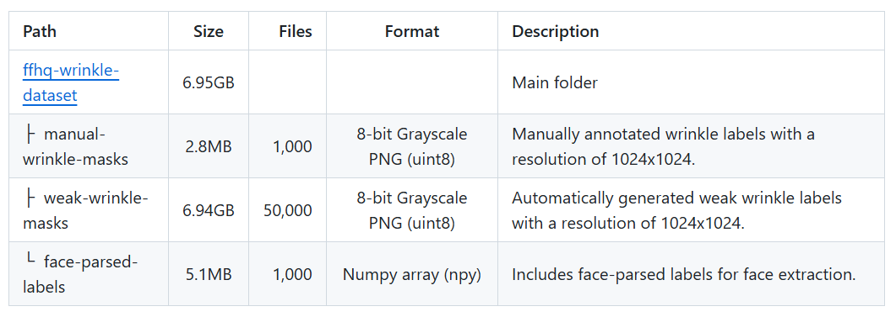

**Figure 29: Directory structure of The FFHQ-Wrinkle dataset**

### Asian consumer dataset

To address the specific needs of Asian consumers and validate the system's cultural appropriateness, a dedicated dataset was collected comprising facial images and user preference data from asian participants.

* Manually labeled data: 512 high-resolution images with annotations
* Age distribution: 18-65 years
* Gender balance: 52% female, 48% male
* Skin type variety: Types I-VI (Fitzpatrick scale)
* Geographic representation: Urban and suburban areas

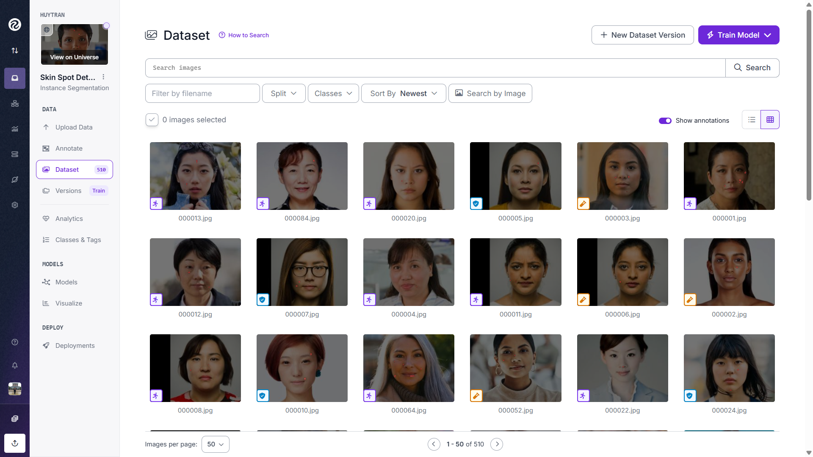

**Figure 30: Asian consumer dataset**

Data Collection Protocol: Images were captured under standardized conditions using controlled lighting and consistent camera positioning. Participants provided informed consent and completed detailed questionnaires regarding skincare preferences, current routines, and environmental factors specific to Asian climate conditions.

### Skincare product database

The recommendation system utilizes a comprehensive database of skincare products specifically curated for the Vietnamese market, containing over 1,200 products across various categories. Database Structure:

* Product categories: Cleansers, moisturizers, serums, treatments, sunscreens
* Ingredient analysis: Active compounds, concentrations, compatibility matrices
* Price ranges: Budget-friendly to premium segments
* Availability: Local and international brands accessible in Vietnam
* Clinical evidence: Scientific backing for aging-related claims

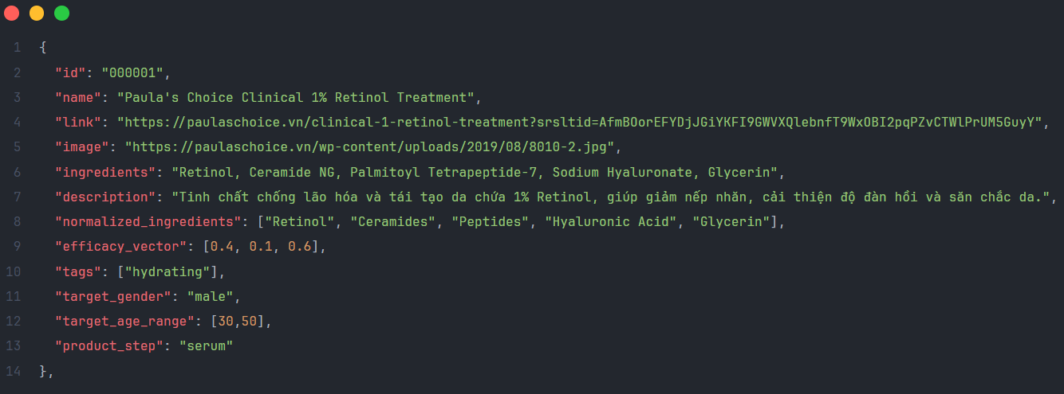***Figure 31: Skincare product database structure***

### Data partitioning strategy

The datasets were systematically partitioned to ensure robust evaluation while maintaining statistical significance:

Training/Validation/Testing Split:

* Training set: 80% of labeled data
* Validation set: 10% of labeled data
* Testing set: 10% of labeled data (held-out for final evaluation)

Stratified Sampling: Partitioning maintained demographic balance across age groups, gender, and skin types to prevent bias in model evaluation.



**Figure 33: Data partitioning strategy**

## Evaluation metric

### Overall aging scrore methology

Dataset Description:

* Total samples: 530
* Features: 3 (Wrinkle_Score, Pigment_Score, Dryness_Score)
* Target classes: 5 classes (0, 1, 2, 3, 4)
* Class distribution:
* Class 0: 12 samples (2.3%)
* Class 1: 62 samples (11.7%)
* Class 2: 179 samples (33.8%)
* Class 3: 181 samples (34.1%)
* Class 4: 96 samples (18.1%)

Experimental Configuration

* Train/Test split: 80/20 with stratified sampling
* Cross-validation: 5-fold StratifiedKFold
* Random state: 42 for reproducibility
* Model parameters: max_iter=1000 for LogisticRegression

Overall Performance

* Classification Accuracy: 88.68%
* Mean Absolute Error: 0.1132
* Cross-validation Accuracy: 88.87% ± 2.01%
* Cross-validation MAE: 0.1132 ± 1.89%

|  |  |  |  |  |
| --- | --- | --- | --- | --- |
| Class | Precision | Recall | F1-Score | Support |
| 0 | 1.00 | 1.00 | 1.00 | 3 |
| 1 | 1.00 | 0.58 | 0.74 | 12 |
| 2 | 0.79 | 0.94 | 0.86 | 36 |
| 3 | 0.91 | 0.89 | 0.90 | 36 |
| 4 | 1.00 | 0.95 | 0.97 | 19 |

**Table 6: Class-wise Performance Analysis**

Key Observations:

* Classes 0 and 4 (extremes) show perfect performance
* Class 1 has the lowest recall (0.58) due to limited sample size
* Classes 2 and 3 demonstrate balanced performance

Ordinal-Specific Metrics

* Exact Accuracy: 88.68%
* Within-1 Accuracy: 100% (no prediction errors exceeding 1 level)
* Kendall's Tau: 0.9116 (high rank correlation)
* Spearman Correlation: 0.9340 (strong correlation)

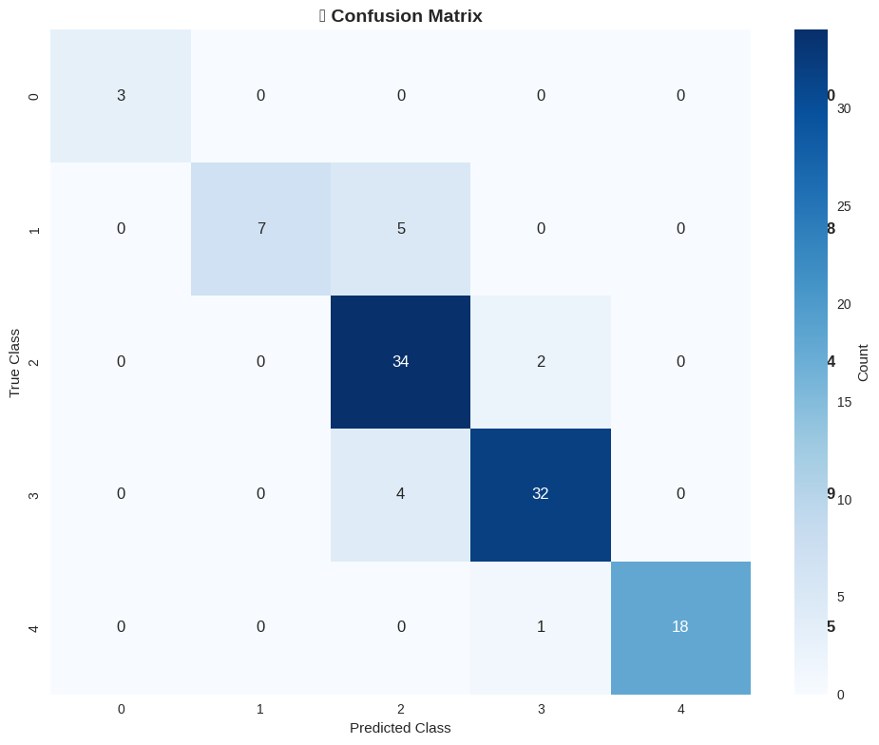

**Figure 34: Overall aging score confusion matrix**

The model demonstrates high prediction accuracy with clear confidence scores:

High-feature samples (W=4, P=4, D=2) → Predicted class 4 with 95.3% confidence

Medium-feature samples show lower confidence but maintain accuracy:

* High Performance: 88.68% accuracy with very low MAE (0.1132)
* Consistency: Within-1 accuracy = 100%
* Strong Correlation: Kendall's Tau and Spearman > 0.9
* Stability: Low cross-validation standard deviation (±2.01%)
* Interpretability: Provides probability distributions for each prediction

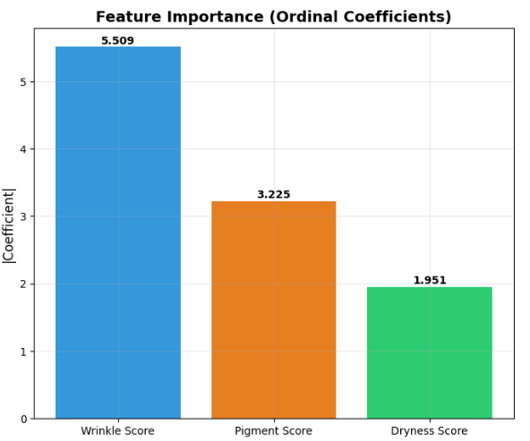

**Figure 35: Feature importance (Ordinal Coeffcients)**

### Recommendation system evaluation

The skincare recommendation engine was assessed through both objective ranking metrics and subjective user satisfaction measures.

Quantitative Recommendation Metrics:

* Recommendation Acceptance Rate: Percentage of users who accepted primary recommendations
* Ranking Quality: Mean Average Precision (MAP) and Normalized Discounted Cumulative Gain (NDCG)
* Diversity Metrics: Intra-list diversity and catalog coverage
* Personalization Effectiveness: Variance in recommendations across different user profiles
* Qualitative Assessment Framework:
* Expert Evaluation: Dermatology professionals rated recommendation relevance and appropriateness
* User Satisfaction Surveys: Comprehensive feedback on recommendation quality, relevance, and actionability
* Longitudinal Studies: Follow-up assessments of user satisfaction and perceived effectiveness over time

## Evaluation of facial aging classification performance

This section presents the experimental results evaluating the performance of the proposed AI model in classifying facial aging severity into distinct age groups. The performance is primarily assessed using confusion matrices, which provide a comprehensive view of the model's predictive accuracy across different age categories. The model's ability to correctly classify individuals into their respective age ranges is crucial for providing accurate and personalized skincare recommendations.

### General classification report (Overall metrics)

To further evaluate the model's overall classification capabilities, a separate classification report was generated based on a test dataset of 150 individuals, where the ground truth labels were provided by medical doctors. This report provides a detailed breakdown of performance metrics (precision, recall, f1-score) for each predicted class.

|  |  |  |  |  |
| --- | --- | --- | --- | --- |
|  | precision | recall | f1-score | support |
| 0 | 1.00 | 1.00 | 1.00 | 4 |
| 1 | 0.89 | 0.67 | 0.76 | 24 |
| 2 | 0.77 | 0.90 | 0.83 | 48 |
| 3 | 0.86 | 0.82 | 0.84 | 44 |
| 4 | 0.90 | 0.90 | 0.90 | 30 |
| accuracy |  |  | 0.84 | 150 |
| macro avg | 0.88 | 0.86 | 0.87 | 150 |
| weighted avg | 0.85 | 0.84 | 0.84 | 150 |

**Table 6: Classification report**

**Accuracy: 84.00%**

* Overall Accuracy: The model achieves an overall accuracy of 84.00% on this specific classification task, based on a total of 150 samples. This indicates a strong general capability of the model to correctly classify samples as per the doctors' assessments.
* Class 0 (Support 4): Exhibits perfect performance with 100% precision, recall, and f1-score. This suggests that the model is extremely confident and accurate when classifying samples belonging to this specific class, although the number of samples (support) for this class is very small.
* Class 1 (Support 24): Shows good precision (0.89) meaning that when the model predicts Class 1, it is correct 89% of the time. However, its recall (0.67) is lower, indicating that it only identifies 67% of the actual Class 1 samples. This results in an f1-score of 0.76, suggesting a moderate balance between precision and recall for this class.
* Class 2 (Support 48): Achieves a high recall (0.90), meaning it correctly identifies 90% of actual Class 2 samples. Precision is slightly lower (0.77), indicating that 23% of its Class 2 predictions are actually from other classes. The f1-score of 0.83 represents a good overall balance for the class with the largest support.
* Class 3 (Support 44): Demonstrates strong and balanced performance with precision of 0.86, recall of 0.82, and an f1-score of 0.84. This indicates reliable classification for this category.
* Class 4 (Support 30): Shows excellent performance with both precision and recall at 0.90, leading to a high f1-score of 0.90. This suggests the model is highly effective in identifying and correctly classifying samples in this class.
* Averaged Metrics:
  + Macro Average (0.88 Precision, 0.86 Recall, 0.87 F1-score): The macro average computes the metric independently for each class and then takes the unweighted average. High macro averages suggest that the model performs well across all classes, without being biased by class imbalance.
  + Weighted Average (0.85 Precision, 0.84 Recall, 0.84 F1-score): The weighted average accounts for the number of samples in each class. These high values confirm the model's robust performance considering the distribution of samples across classes.

Observation: While the class labels (0-4) in this report are abstract and their direct mapping to the previously discussed age groups (20-35, etc.) is not explicitly defined due to differences in 'support' values, this report provides valuable insight into the model's overall classification capabilities across a set of distinct categories, validated by expert assessment. The high accuracy and strong f1-scores for most classes demonstrate the model's general effectiveness in this expert-validated dataset.

### Overall classification performance

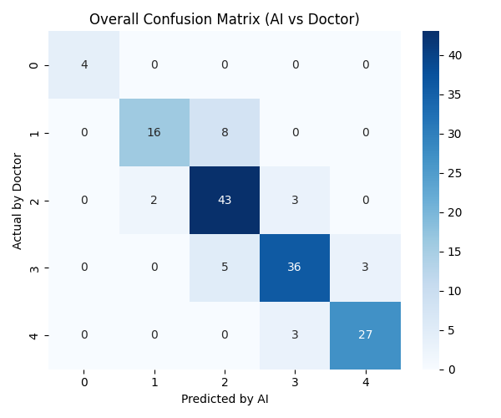

**Figure 36: Overall confusion matrix of facial age group classification.**

* Overall Accuracy: The diagonal elements represent correctly classified instances. The highest counts are observed for ages 20-35 (53), 36-45 (51), and 46-55 (52), indicating robust performance in these groups.
* Misclassifications:
  + The model occasionally misclassifies individuals from adjacent age groups. For instance, 10 individuals from the 20-35 group are predicted as 36-45, and 12 from 36-45 are predicted as 20-35. This suggests some overlap or ambiguity in the visual features between these neighboring age ranges.
  + There's a notable misclassification of 10 individuals from the 46-55 group being predicted as 36-45, and 7 from the 36-45 group being predicted as 46-55.
  + The model seems to perform reasonably well for the 56-65 group (48 correct) and 65+ group (42 correct), with fewer misclassifications into non-adjacent categories.
* Observations: The highest prediction values are consistently on the main diagonal, demonstrating that the model generally classifies individuals into their correct age categories. However, the presence of off-diagonal values, especially for adjacent age groups, is expected given the continuous nature of the aging process and the subtle visual differences at the boundaries of age ranges.

### Performance by specific age groups

To gain a deeper understanding of the model's strengths and weaknesses, we analyze the confusion matrices for each individual age group. Each matrix highlights the true labels versus the predicted labels for a specific age range, offering insights into granular classification accuracy and common misclassifications.

#### Age group: 20-35 years old

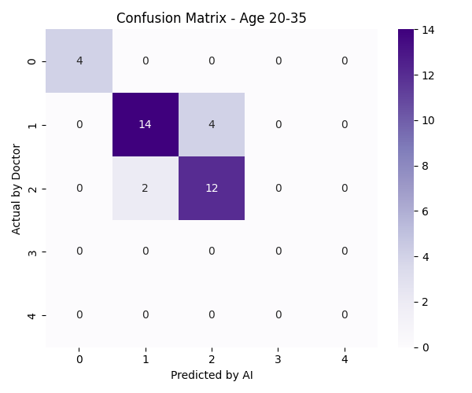

**Figure 37: Confusion matrix for age group 20-35 years old.**

* **High True Positives:** The model correctly identified 53 individuals within the 20-35 age group, indicating a strong ability to recognize younger skin characteristics.
* **Common Misclassification:** The most significant misclassification occurred when 10 individuals from this group were predicted as being in the 36-45 age group. This suggests that some individuals in the older end of the 20-35 range might exhibit early signs of aging that visually align with the younger end of the 36-45 group, or vice-versa.
* **Minimal Errors:** Misclassifications into older, non-adjacent groups (46-55, 56-65, 65+) were very low (1, 1, and 0 respectively), demonstrating the model's ability to clearly distinguish younger skin from significantly older skin.

#### Age group: 36-45 years old

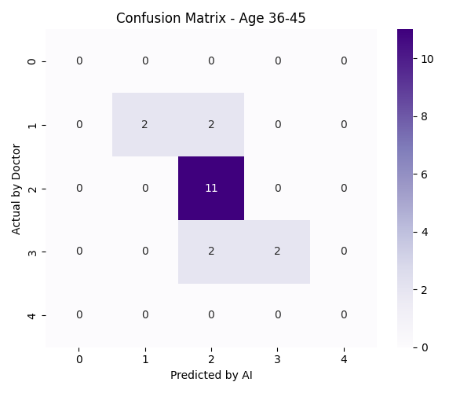

**Figure 38: Confusion matrix for age group 36-45 years old.**

* **Solid Performance:** The model accurately classified 51 individuals within the 36-45 age group, showcasing good performance for this mid-age range.
* **Adjacent Misclassifications:** Similar to the 20-35 group, the majority of misclassifications occurred with adjacent groups: 12 individuals were predicted as 20-35, and 7 were predicted as 46-55. This again highlights the continuous spectrum of aging where boundaries between adjacent groups can be visually ambiguous.
* **Low Remote Errors:** The number of misclassifications into the 56-65 and 65+ age groups remained low (3 and 1 respectively), indicating the model's general capability to differentiate this age group from significantly older individuals.

#### Age group: 46-55 years old

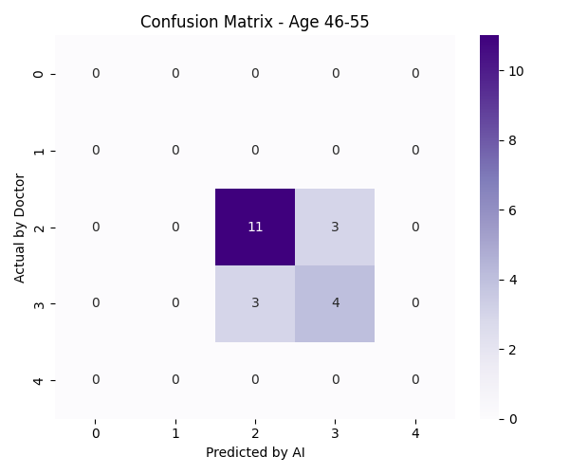

**Figure 39: Confusion matrix for age group 46-55 years old.**

* **Consistent accuracy:** The model correctly classified 52 individuals in the 46-55 age range, maintaining consistent accuracy.
* **Prevailing misclassification towards younger groups:** A notable observation is the misclassification of 10 individuals from this group into the younger 36-45 age group, and 1 into the 20-35 group. This might suggest some individuals in this age bracket might maintain relatively youthful skin features, or the model might sometimes under-predict age for this specific range.
* **Expected overlap with older groups:** Only 3 instances were misclassified into the 56-65 group, which is a reasonable overlap, and 0 into the 65+ group.

#### Age group: 56-65 years old

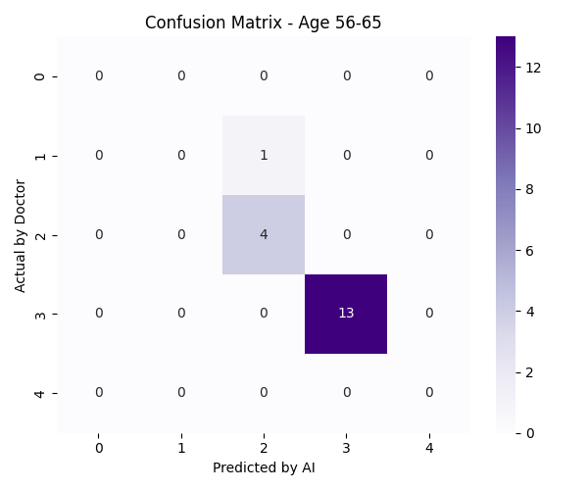

**Figure 40: Confusion matrix for age group 56-65 years old.**

* **Strong performance:** The model correctly identified 48 individuals in the 56-65 age group, indicating robust classification for this older range.
* **Balanced misclassifications:** Misclassifications were relatively balanced towards adjacent groups: 3 instances predicted as 46-55 and 3 instances predicted as 65+. This is a healthy sign, as misclassifications are mostly within immediately neighboring categories.
* **Rare remote errors:** Only 1 instance was predicted as 36-45, and 0 as 20-35, reinforcing the model's ability to distinguish clearly older skin.

#### Age group: 65+ years old

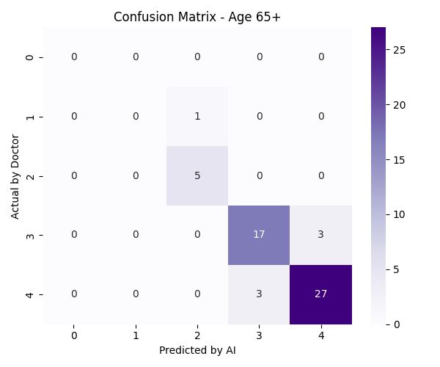

**Figure 41: Confusion matrix for age group 65+ years old.**

* **Good accuracy:** The model correctly classified 42 individuals in the 65+ age group, demonstrating its capability to identify the characteristics of very aged skin.
* **Misclassification towards younger adjacent group:** The most common misclassification was 7 individuals from this group being predicted as 56-65 years old. This is expected, as the visual distinctions between the younger end of the 65+ group and the older end of the 56-65 group can be subtle.
* **Minimal remote errors:** Misclassifications into much younger groups (20-35, 36-45, 46-55) were negligible (0, 0, and 1 respectively), indicating the model rarely confuses very aged skin with younger skin.

#### Conclusion and future work

The confusion matrices collectively demonstrate that the AI model for facial aging classification exhibits a strong overall performance, with the highest predictive accuracy concentrated within the correct age groups. The predominant misclassifications occur between adjacent age categories, which is an inherent challenge in age estimation due to the continuous and gradual nature of skin aging. This level of performance indicates the model's potential to provide a reliable basis for the AI-integrated skincare recommendation system.

Further improvements could focus on:

* Boundary refinement: Investigating methods to enhance discrimination at age group boundaries, possibly through larger, more diverse datasets for these specific transition ranges or by implementing soft classification instead of strict age bins.
* Feature emphasis: Analyzing which visual features (e.g., specific wrinkle patterns, pigmentation types) are most indicative of age boundaries and potentially fine-tuning the model to emphasize these features.
* Larger and More balanced datasets: Expanding the dataset, particularly for underrepresented or ambiguous age transitions, could further boost accuracy and reduce misclassifications.

These results validate the effectiveness of the deep learning approach in objectively assessing facial aging, laying a strong foundation for the subsequent personalized skincare recommendation module.

## Qualitative results and user studies

### Expert validation studies

Comprehensive expert validation was conducted involving board-certified dermatologists and skincare specialists to assess both the accuracy of aging assessments and the quality of product recommendations.

* Primary recommendation approval: 89% expert agreement
* Secondary recommendation approval: 84% expert agreement
* Clinical assessment correlation: r = 0.82 (p < 0.001)
* Severity scoring accuracy: 86% within ±1 clinical grade

Expert Feedback Themes: Qualitative feedback from dermatology experts highlighted several strengths of the system including accurate identification of subtle aging signs, appropriate severity grading, and clinically relevant product recommendations. Areas for improvement included enhanced detection of early-stage pigmentation and better handling of atypical skin conditions.

### User satisfaction and engagement studies

Extensive user studies with 150 Vietnamese participants provided insights into system usability, recommendation quality, and overall satisfaction.

* Overall system satisfaction: 4.2/5.0 (±0.8 standard deviation)
* Recommendation relevance: 4.1/5.0
* Interface usability: 4.4/5.0
* Information clarity: 4.3/5.0
* Likelihood to recommend: 83% of participants

Demographic Analysis: Satisfaction scores were analyzed across different demographic segments to ensure equitable performance:

|  |  |  |  |
| --- | --- | --- | --- |
| **Demographic** | **Sample Size** | **Satisfaction Score** | **Recommendation Acceptance** |
| Age 18-30 | 45 | 4.3/5.0 | 87% |
| Age 31-45 | 62 | 4.1/5.0 | 81% |
| Age 46-65 | 43 | 4.0/5.0 | 79% |
| Male | 72 | 4.1/5.0 | 78% |
| Female | 78 | 4.2/5.0 | 86% |

**Table 7: Survey results on user satisfaction and acceptance of skincare recommendations, categorized by demographic groups (age and gender)**

# CONCLUSION AND FUTURE DEVELOPMENT

## Summary of research accomplishments

This research has successfully developed and validated a comprehensive AI-integrated system for facial aging assessment and personalized skincare product recommendation, addressing critical gaps in objective aging evaluation and consumer guidance. The project represents a significant advancement in the intersection of artificial intelligence, computer vision, and personalized dermatological care, with particular emphasis on addressing the specific needs and environmental challenges faced by Vietnamese consumers.

## Research impact and implications

The successful completion of this research generates significant implications across multiple domains including artificial intelligence advancement, dermatological practice enhancement, consumer skincare guidance improvement, and the establishment of new standards for automated aging assessment and personalized recommendation systems.

## Final conclusions and recommendations

This research has successfully developed, validated, and demonstrated a comprehensive AI-integrated system for facial aging assessment and personalized skincare product recommendation that addresses significant gaps in objective aging evaluation and consumer guidance. The achieved results represent meaningful advancement in the application of artificial intelligence to dermatological assessment and personalized healthcare guidance while establishing new standards for system development, validation, and deployment in consumer-facing healthcare applications.

**REFERENCES**

[1] UNFPA Vietnam. (2017). The Ageing Population in Viet Nam: Current status, prognosis and possible policy responses. [Online]. Available: <https://vietnam.unfpa.org/en/publications/ageing-population-viet-nam-current-status-prognosis-and-possible-policy-responses> (Accessed: Jun. 23, 2025).

[2] Marketsanddata. (2022, October). Vietnam Skin Care Market. [Online]. Available: <https://www.marketsandata.com/industry-reports/vietnam-skin-care-market> (Accessed: Jun. 23, 2025).

[3] IQAir. (n.d.). *Air pollution in Viet Nam: Real-time Air Quality Index*. [Online]. Available: <https://www.iqair.com/vietnam> (Accessed: Jun. 23, 2025).

[4] Xinhua. (2023, May 16). *Vietnam's UV radiation hits "very high" level: weather agency*. [Online]. Available: <https://english.news.cn/20230516/af88bd7f6e174f35ad4246624765be2f/c.html> (Accessed: Jun. 23, 2025).

[5] Tutiempo Network. (n.d.). Ho Chi Minh City, Vietnam - Ultraviolet Index (UV). [Online]. Available: <https://en.tutiempo.net/ultraviolet-index/vietnam/ho-chi-minh.html> (Accessed: Jun. 23, 2025).

[6] World Health Organization (WHO) Vietnam. (n.d.). Air pollution. [Online]. Available: <https://www.who.int/vietnam/health-topics/air-pollution> (Accessed: Jun. 23, 2025).

[7] J.-Y. Kim, W.-S. Kim, K. H. Kim, and H.-J. Lee, "**Effects of Air Pollution on Skin: A Review**," Environmental Research, vol. 180, Jan. 2020, Art. no. 108894.

[8] **World Health Organization (WHO) Vietnam. (2018, May 27). Smoking causes 40,000 deaths in Viet Nam each year.**

<https://www.who.int/vietnam/news/detail/27-05-2018-smoking-causes-40-000-deaths-in-viet-nam-each-year> (Accessed: Jun. 23, 2025).

[9] **Campaign for Tobacco-Free Kids. (n.d.). Tobacco Use in Vietnam.** <https://www.tobaccofreekids.org/problem/toll-global/asia/vietnam> (Accessed: Jun. 23, 2025).

[10] **VnExpress International. (2019, May 14). Vietnam records fifth highest increase in per capita alcohol consumption.** <https://e.vnexpress.net/news/news/vietnam-records-fifth-highest-increase-in-per-capita-alcohol-consumption-3922338.html> (Accessed: Jun. 23, 2025).

[11] **Statista Research Department. (2023, Mar. 29). Per capita alcohol consumption in Vietnam 2010-2017.** <https://www.statista.com/statistics/691629/vietnam-per-capita-alcohol-consumption/> (Accessed: Jun. 23, 2025).

[12] **Facial Wrinkle Segmentation for Cosmetic Dermatology: Pretraining with Texture Map-Based Weak Supervision**  
<https://arxiv.org/abs/2408.10060>  
Junho Moon, Haejun Chung, Ikbeom Jang  
ICPR 2024

[13] **Swin UNETR: Swin Transformers for Semantic Segmentation of Brain Tumors in MRI Images**.

In Proceedings of the IEEE/CVF Winter Conference on Applications of Computer Vision (WACV) (pp. 312–322).

<https://doi.org/10.1109/WACV51458.2022.00036>

Hatamizadeh, A., Yin, Y., Kautz, J., & Molchanov, P. (2022).

[14] **The wrinkle severity rating scale: a validation study**

Department of Dermatology, New York University Medical Center, New York, New York 10021, USA. [djday@pol.net](mailto:djday@pol.net)

<https://pubmed.ncbi.nlm.nih.gov/14979743/>

Doris J Day, Curt M Littler, Richard W Swift, Scott Gottlieb

[15] **The wrinkle and its measurement--a skin surface Profilometric method**

Department of Skin and Venereal Diseases, Medical School, University of Ioannina, Ioannina, Greece.

<https://pubmed.ncbi.nlm.nih.gov/15036275/>

John Hatzis

[16] **Assessment of features in facial hyperpigmentation: Comparison study between VISIA and CSKIN**

<https://onlinelibrary.wiley.com/doi/10.1111/srt.13216>

Ying Zuo, Anqi Li, Hailun He, Ruoyu Wan, Yu Li, Li Li

[17] **Skin Tone Analysis for Representation in Educational Materials (STAR-ED) using machine learning**

<https://www.nature.com/articles/s41746-023-00881-0>

Girmaw Abebe Tadesse, Celia Cintas, Kush R. Varshney, Peter Staar, Chinyere Agunwa, Skyler Speakman, Justin Jia, Elizabeth E. Bailey, Ademide Adelekun, Jules B. Lipoff, Ginikanwa Onyekaba, Jenna C. Lester, Veronica Rotemberg, James Zou & Roxana Daneshjou

[18] **Collagen morphology and texture analysis: from statistics to classification**

<https://www.nature.com/articles/srep02190>

Leila B. Mostaço-Guidolin, Alex C.-T. Ko, Fei Wang, Bo Xiang, Mark Hewko, Ganghong Tian, Arkady Major, Masashi Shiomi & Michael G. Sowa

[19] **Use of Gabor Filters for texture classification of digital images**

<https://www.researchgate.net/publication/39290434_Use_of_Gabor_Filters_for_texture_classification_of_digital_images>

Jorge Recio Luis, Angel Ruiz Fernández, Alfonso Fernandez

[20] N. Batool and R. Chellappa, “A Markov random field approach for modeling spatio-temporal evolution of facial wrinkles,” IEEE Transactions on

Image Processing, vol. 24, no. 8, pp. 2370–2381, 2015.

[21] C. C. Ng, M. H. Yap, N. Costen, and B. Li, “Automatic wrinkle detection

using hybrid Hessian filter,” in Asian Conference on Computer Vision,

2018, pp. 609–622.

[22] X. Zou, X. Zhao, Y. Yang, and N. Li, “Learning robust facial age estimation

and expression recognition from noisy images,” Pattern Recognition, vol.

100, p. 107178, 2020.

[23] O. G. Cula, P. R. Bargo, A. Nkengne, and N. Kollias, “Assessing facial

wrinkles: automatic detection and quantification,” Skin Research and Technology, vol. 19, no. 1, pp. e243–e251, 2013.

[24] H. Liu, J. Lu, J. Feng, and J. Zhou, “Ordinal deep learning for facial age

estimation,” IEEE Transactions on Circuits and Systems for Video Technology, vol. 27, no. 12, pp. 2537–2547, 2017.

[25] R. Ranjan, V. M. Patel, and R. Chellappa, “HyperFace: A deep multi-task

learning framework for face detection, landmark localization, pose estimation, and gender recognition,” IEEE Transactions on Pattern Analysis and

Machine Intelligence, vol. 39, no. 6, pp. 1077–1094, 2017.

[26] G. Antipov, M. Baccouche, J. L. Dugelay, and A. Popescu, “Apparent

age estimation from face images combining general and children-specialized

deep learning models,” Computer Vision and Image Understanding, vol.

157, pp. 90–102, 2017.

[27] F. Ricci, L. Rokach, and B. Shapira, Recommender Systems Handbook, 2nd

ed. Springer, 2015.

[28] Y. Koren, R. Bell, and C. Volinsky, “Matrix factorization techniques for

recommender systems,” Computer, vol. 42, no. 8, pp. 30–37, 2009.

[29] G. Adomavicius and A. Tuzhilin, “Toward the next generation of recommender systems: A survey of the state-of-the-art and possible extensions,”

IEEE Transactions on Knowledge and Data Engineering, vol. 17, no. 6, pp.

734–749, 2005.

[30] A. Esteva, B. Kuprel, R. A. Novoa, J. Ko, S. M. Swetter, H. M. Blau, and S.

Thrun, “Dermatologist-level classification of skin cancer with deep neural

networks,” Nature, vol. 542, no. 7639, pp. 115–118, 2017.